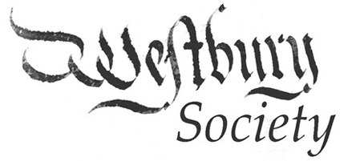

Report to 2025 Annual Parish Meeting

During the last twelve months, the Westbury Society has carried on its normal programme of Autumn and Winter talks. Subjects included nature recovery, eel reintroduction and an online talk about the importance of hedges. The annual Barry Lane Lecture was given by Dr Jodie Lewis about her archaeological investigations in Priddy, and was particularly well attended.

The 19th annual glow-worm count took place at the end of July. Forty-one people spread out around the parish, walking the same routes as in previous years. Only 53 glow-worms were found, the lowest total so far; the reason for this may be the unusually wet 23/24 winter.

The Society’s archaeology group continues to excavate the Romano-British farmhouse below Hollybrook. The site was flooded during the winter, but the group remained active identifying and recording pottery and animal finds from the site and by visiting other archaeological sites and archives.

The Society’s programme for 2025-2026 is already mapped out with speakers booked for five of the six lecture dates.

