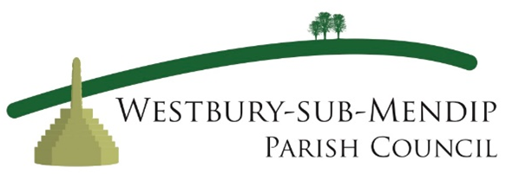

Dates of Westbury-Sub-Mendip Parish Council Meetings
May 2025 – June 2026

Meetings are held on the first Wednesday of the month
and take place in Westbury Sub Mendip Village Hall

Wednesday 7 May 2025
Wednesday 14 May (Annual Parish Meeting) 2025
Wednesday 4 June 2025
Wednesday 2 July 2025
No Meeting in August
Wednesday 3 September 2025
Wednesday 1 October 2025
Wednesday 5 November 2025
Wednesday 3 December 2025
Wednesday 7 January 2026
Wednesday 4 February 2026
Wednesday 4 March 2026
Wednesday 1 April 2026
Wednesday 6 May (plus AGM) 2026
Wednesday 3 June 2026

