

Westbury-sub-Mendip

**Tuesday 8th October 2024**

**7.30pm**

**Westbury Village Hall**

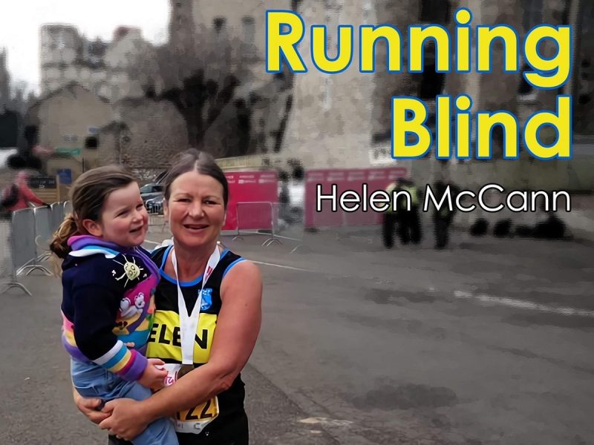

**Helen had lived with hearing loss all her life, but had no idea that she would also lose her sight by the time she was 40. Incredibly, Helen’s journey led her to running, fundraising and even writing a book! She will be telling us her story…**

**Everyone welcome, visitors £4.50**

**For more details contact Sue 01749 870618**