
GAZA CRISIS APPEAL
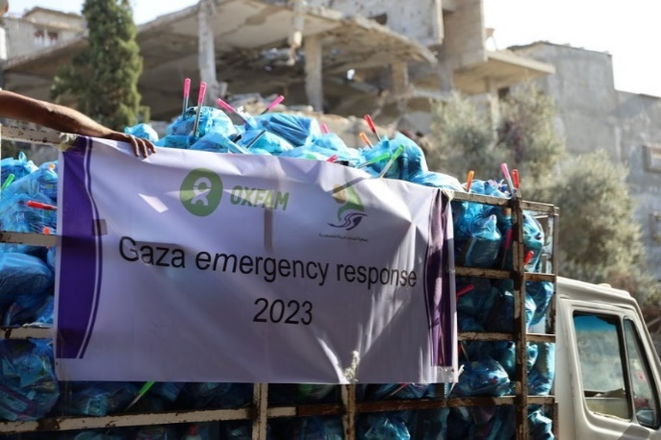
POP-UP CAFÉ
Saturday 10th February
10-12.30
Easton Village Hall
Tea, coffee, home-made cakes
Raffle and Bring and Buy
All proceeds to
 GAZA CRISIS APPEAL

