Westbury-sub-Mendip

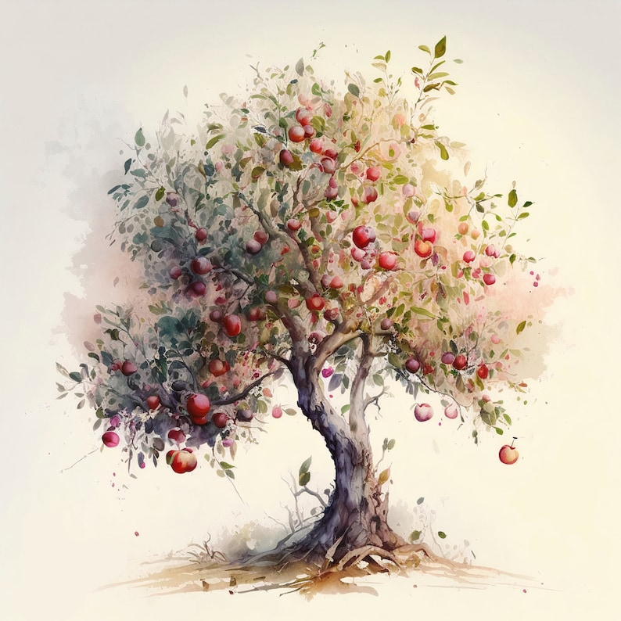
Tuesday 10th October 2023
7.30pm
Westbury Village Hall

MICK FLETCHER
will be talking about
CIDER , APPLES AND TREES-

an accidental journey

everyone welcome, visitors £4.50
For more details contact Sue 870618

