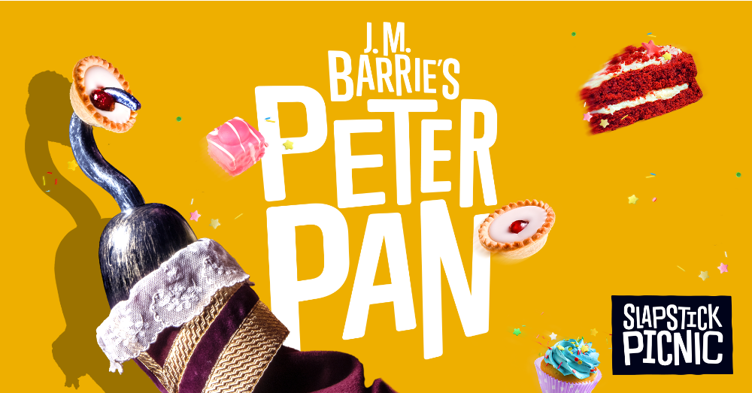

Save the date - Peter Pan flies into Westbury Playing Fields - Thurs 3 August 7pm

This summer, Slapstick Picnic is whipping up a theatrical treat like no other in outdoor venues all across the UK: a three-actor production of J.M.Barrie’s classic play Peter Pan.
Slapstick Picnic is a sister company of The Handelbards who have appeared in Westbury before to great acclaim.
Let your imagination soar as they dish out this timeless tale of hapless pirates, feral children and a particularly punctual reptile. This show isn’t just for kids; their brilliant buffoonery will have picnickers of all ages cackling into their coleslaw.

This is one flight of fancy you don’t want to miss and courtesy of the Parish Council, Footlights and local businesses it is free entry!
To help us predict numbers entry will be by ticket ,available shortly from the village shop.

So bring your own picnic, rugs, chairs and soft drinks (no glass please). But if that’s too much hassle we have also booked Soul Dough who will make you banging wood fired pizzas and expect to have a pay bar. If you enjoy yourselves then we will be asking for donations so we can go on providing good entertainment for everyone in the community.

WATCH OUT FOR POSTERS AROUND THE VILLAGE – AND TELL YOUR FRIENDS
MORE INFORMATION FROM SUE ISHERWOOD 01749 870457

