The Friends of Westbury Church
Invite you to join us for a
Winter Warmer Lunch
Thursday 3rd November 2022
12 noon for 12.30pm in The Village Hall
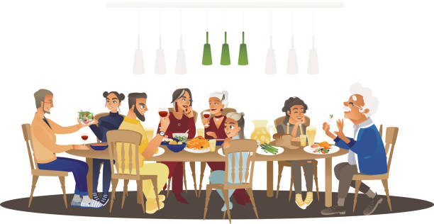
£15.00
***
Free drink on arrival
***
Main course with vegetarian option
Selection of desserts, including gluten free choices
Coffee or tea
BYO Wine ***** RAFFLE

Tickets : - Shop and committee or call Pippa on 870042

