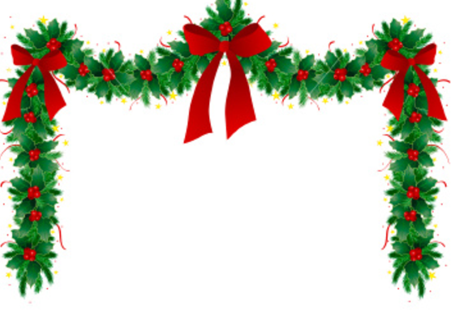
Coffee, Crafts And Cakes
For Christmas
Westbury Village Hall

SATURDAY 26TH NOVEMBER 2022
10.30AM – 1.00PM
ENTRY £2.50 INCLUDES REFRESHMENTS
FREE ENTRY FOR CHILDREN UNDER 11
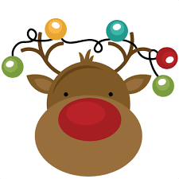
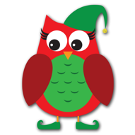
COME AND BUY FROM A VARIETY OF STALLS, INCLUDING;
WHITE ELEPHANT, BOOKS, JEWELLERY, TOYS, TRAIDCRAFT AND RIPPLE EFFECT PLUS A RANGE OF SAVOURIES AND CAKES.

THERE WILL ALSO BE A RAFFLE, GUESS THE WEIGHT OF THE CAKE, CHOOSE A BOTTLE OF WATER/WINE
AND MORE


ANY RAFFLE ITEMS, CAKES AND TRAY BAKES WOULD BE GRATEFULLY RECEIVED AS WOULD A DONATION OF A BOTTLE OF WINE FOR THE CHOOSE A BOTTLE OF WATER/WINE

