Westbury-sub-Mendip

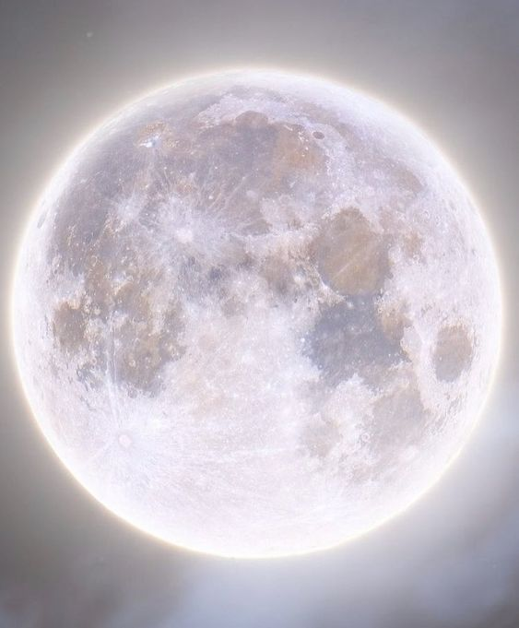

Judith Chubb-Whittle
Landscape Planning officer
Mendip Hills AONB

Talking on
Dark Skies
Westbury Village Hall
Tuesday 12th July 7.30pm

Everyone welcome
Visitors £4.50
For more details call Sue 870618

