Westbury-sub-Mendip

Trio Paradis
Playing Tango
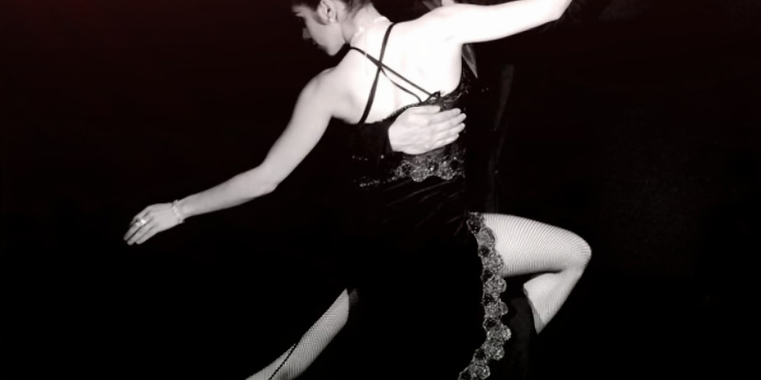
Trio Paradis - Jacquelyn Bevan - piano, Lisa Betteridge - violin & Linda Stocks - cello -
will play a collection of Latin American dances, including tangos by Piazzolla and Bragato,
Along with refreshments including home-made cakes.
We hope that you would like to join us.

Westbury Village Hall
Tuesday 8th February 3.00pm
We will be happy to see you. Everyone is welcome
For more details contact Sue 870618

In March the Friends of Westbury Church invite you to an afternoon concert performed by Trio Paradis in St Lawrence's Church. on March 19th. The programme will be based on a flower theme in celebration of the beautiful carpet of primroses at this time of year.

