Response to the Consultation for the Church Commissioners proposal for Roughmoor Lane Living as per website.
www.roughmoorlaneliving.com

Impressions: There are 41 buildings on the plan excluding garages and there are 6 buildings with pink multiple parking spaces that I presume are ‘flats’ or ‘terrace’. To get to UP TO 60 dwellings this suggests that each of these 6 is 4 dwellings so that 35 detached and 24 flats of terrace dwellings get to about 60. The gardens are more or less 10m long and less in width. By comparison with the houses in much of the village this is very small. I think that this density of housing is not appropriate in this rural setting and in the context of Westbury as it currently is.
There are no 3 storey houses in Westbury that I know of and if there are any, I guess that they are loft conversions rather than purpose built three storey dwellings. An average of 2.5 storeys suggests that half the 41 dwellings would need to be three storeys to give an average of 2.5 storeys. Having any, let alone 20, three storey buildings are therefore, in my view, completely inappropriate in Westbury.
Road width: It looks as if the roads shown within the site are of the order 8m wide which might include pavements (footways) seemingly on both sides. This means that any large delivery vans, fire engines or ambulances will struggle to get past any cars parked on the roads outside such houses. At least the entry and access to Roughmoor Lane needs to recognise that very wide farm machinery will be using the road and the pavement needs to be wide enough to protect pedestrians. I am told that a farm machinery forager is 3m wide so that with turning it is going to be awkward or impossible even on a 5.5m wide carriageway to allow traffic in both directions. Clearly it would need to be much more than this to allow for this and this needs to be shown on the drawings/ plans. How the pedestrians and push chairs will access the shop and school across this access to Roughmoor Lane is ambiguous and probably inadequate at best. These over narrow roads create an unjustified impression of space across the whole site. There will be statutory widths for such roads which will come from making the plots smaller than they already are. In Bell Close the road carriageway is 5.5m and each pavement (footway) is 2m, so the edge-to-edge width is 9.5m - pavement, carriageway, pavement. People who visit these houses will park on the road so there needs to be sufficient width for such parked cars to allow passage of an ambulance or a fire engine. This is already a problem within Stoneleigh where the roads are not wide enough in places for this parking to allow emergency vehicles to pass.
The trees on the plan look as if they are up to 10m across which is somewhat small and could be 12m or more if they are allowed to grow freely. Again, this adds to the impression that there is more space than there actually is.
Lighting: There is no mention so far, but Westbury-sub-Mendip has a dark skies policy and all the latest information for bats and nocturnal insects is that they benefit from dark skies. I would therefore expect there to be no streetlights in this development. In practice Westbury has been turning off streetlights in the last 15 years or so, following consultations with residents, and there are ongoing efforts to reduce what little street lighting remains still further. See section on glow-worms in Biodiversity Net Gain.
Biodiversity Net Gain: It is vital that all developments take the biodiversity crisis seriously and include real changes that benefit biodiversity. To this end I notice that pre-plan map of the site shows a 12-15m strip labelled ‘Existing hedgerow and bat foraging corridor’. Circled in red.
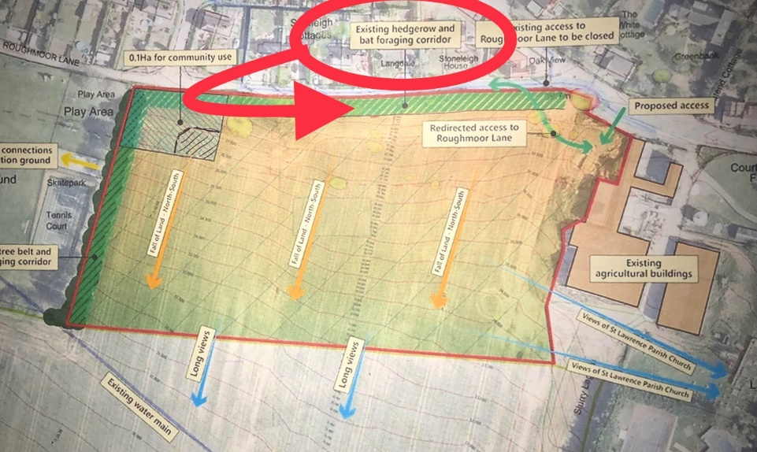

By the time it got to the actual housing plan this strip is barely the width of the red line surrounding the site on the map. This existing hedgerow is nowhere near this width and so for there to be a ‘net gain’ this corridor needs taking seriously.
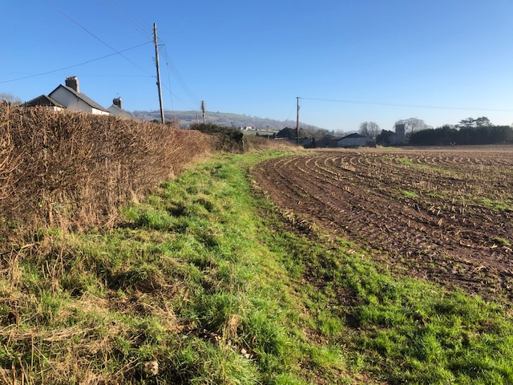
This means that there could be a 12m to 15m bat foraging corridor but only by some effective planting. This extra planting would presumably be included in the 0.13 hectare required for this Biodiversity Net Gain. See diagram below.
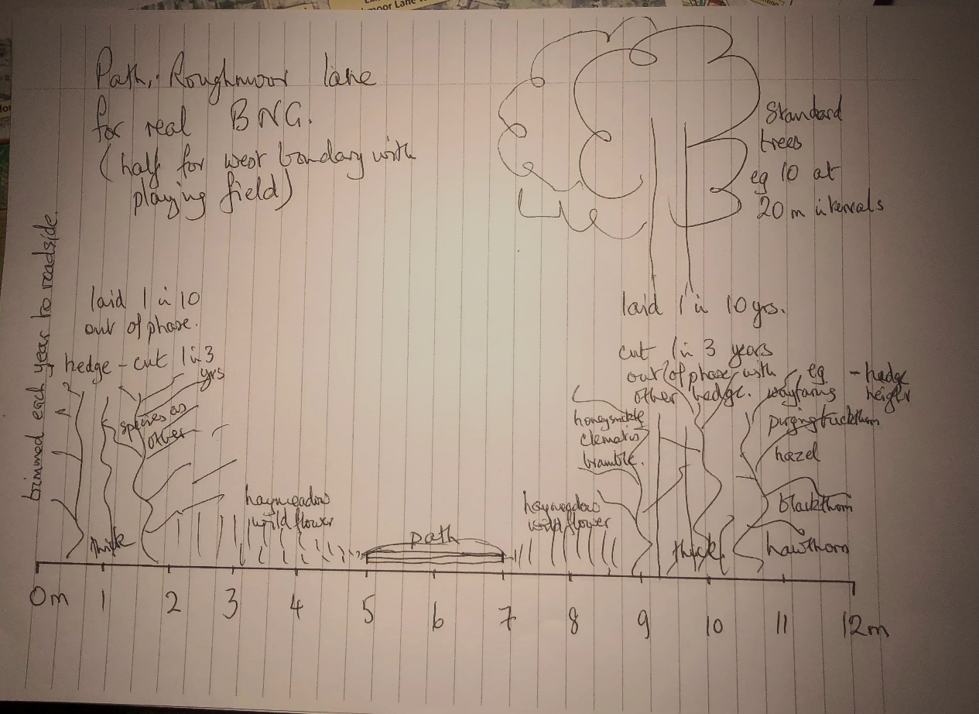
I propose that in this 12m strip there is a hedge up to 3m high on the Roughmoor lane side (left on diagram) of the strip 2 to 2.5m wide. Inside this is a 2 to 2.5 metre strip of hay meadow wildflower grassland, a 2metre width of path, 2 to 2.5 m hay meadow wildflower grassland and then a wider hedge 3- 3.5m with standard trees planted
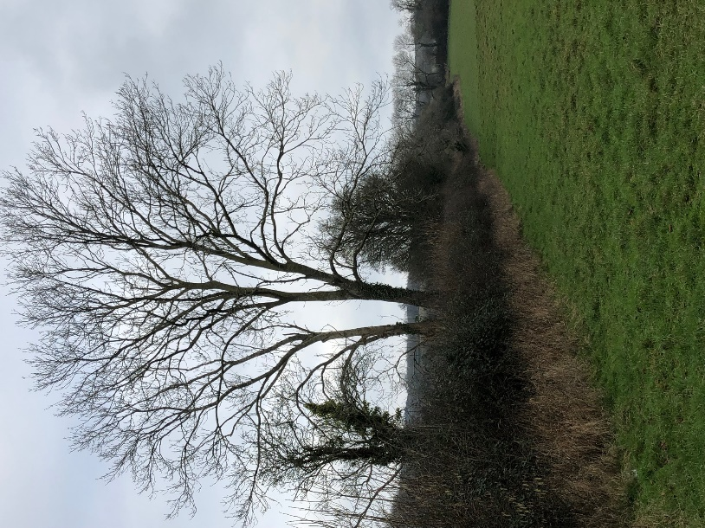 Hedge with standards
at 20m or 25 m intervals along it. This would provide a visual barrier between the Stoneleigh and Roughmoor Lane houses, a path that is off road – and green and pleasant, all the way from the playing field to the junction at the Mortar Pits. It would also be a biodiversity net gain as a bat foraging corridor, as an area with wildflowers for bees and other insects, and suitable habitat (base of hedgerow and rough grass verges) for glow-worms to spread from the northern edge of the playing field where they already exist and have existed since glow worm counts have been made across the Parish since 1993 and annually since 2006. Glow-worms are not found in the Parish where there is street lighting, so it is really important for them that the development is not street lit, and there is sufficient hedgerow thickness and grass verge to support the snails and overwintering sites they require. Roughmoor Lane is the best site in the Parish for glow-worms and groups from the Somerset Wildlife Trust have regularly been taken along Roughmoor Lane every July and August for the last 6 years or more. For the management for biodiversity the hedge should be cut back every third year as it is the 1st and 2nd year growth that supports the caterpillars of moths that provide food for the bats and other insectivorous animals. Similarly, the ‘hay meadow’ could be cut alternate sides of the path each year so that wildflowers and the insects in the grasses have some sward to overwinter below and within on one side of the path or the other. This grassy strip would be wide enough to have wooden seats in if this was felt to be appropriate by the community.
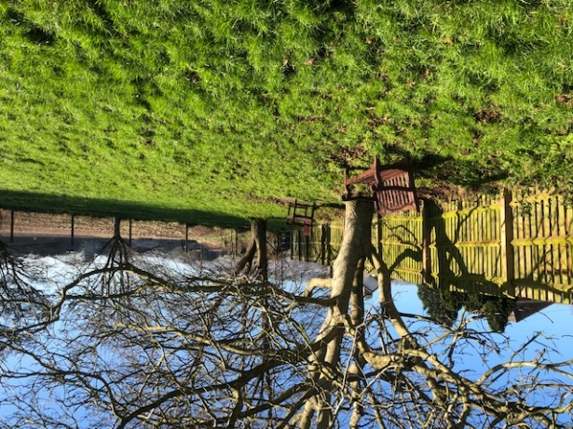
Western boundary of the site: On the pre-plan map there is an ‘existing tree belt and bat foraging corridor’ shown. This is not there! See photo.
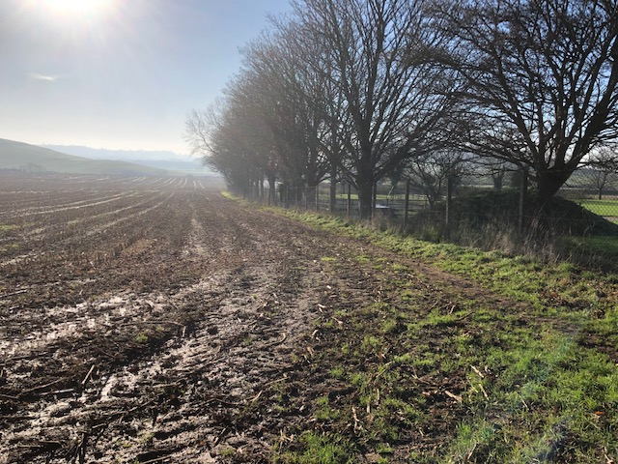
The trees are entirely within the playing field and the boundary of the site of the Plan does not even have any hedge there. Such a hedge should be planted which with the playing field trees would create a good bat foraging corridor. I suggest that there should be a path on the inside of this newly planted hedge so that it would be about half the width of my proposal for the path along the north side of the site parallel to Roughmoor Lane. These two path and hedge proposals would ensure that the ‘bat foraging corridor’ from close to where Roughmoor Lane connects to the A371 would go round the north and west sides of the site. With the encouragement of the Playing field putting in hedging between the trees along the southern and western boundaries, the bat foraging corridor would be connected to the rest of Roughmoor Lane and therefore out onto the wider moor. This would be real biodiversity net gain!!
Swift bricks and bat boxes: There are colonies of swifts, newly red-listed, in the Village that are using houses, swift boxes and swift bricks. With a large number of new houses, it should be possible, and highly desirable, to put swift bricks
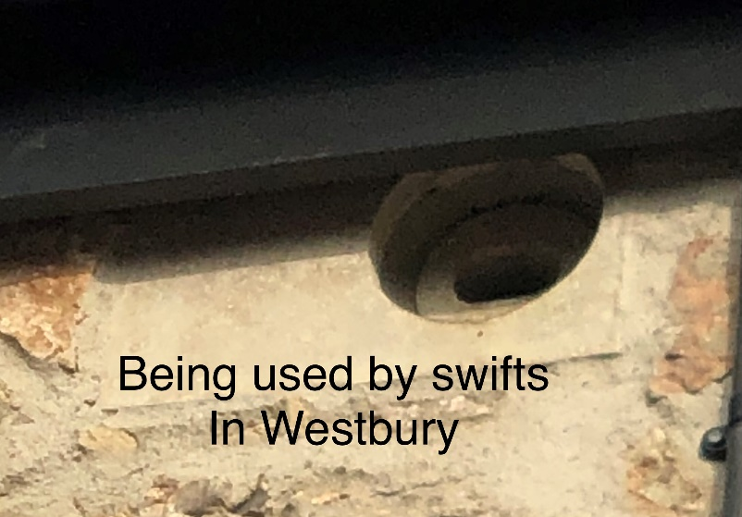
into at least half the houses in which there is a high point and space for the swifts to drop out of the brick nest site and fly off. They are loose colony nesters, and this would have the makings of an opportunity to support a new colony of this threatened species. There has already been one house in Stoneleigh, close by, that has had swifts nesting in it.
In the same vein woodcrete bat boxes could be put onto houses as well – perhaps onto the houses that don’t have swift brick nest sites. The whole development would then be supporting house nesting swifts and house roosting bats. This would be even more Biodiversity Net Gain!
Along the southern boundary of the site water is draining off downhill which could be mitigated by planting a line of trees along the southern boundary as has become customary across much of Mendip and the rest of the country to reduce water runoff.
Community Use site: The site next to the Playing Field is far from ideal for a Village Hall as it is well away from the ‘centre’ of the Village. Indeed the ‘existing agricultural buildings’ area is much more central and would provide the opportunity for any Community building to have access to significant car parking space. Such car parking is already used by the Church when they have hosted weddings, funerals, and the like. If at some future time the Village Hall were to be built there it would be able to use this car parking which is the major drawback of the current Village Hall on Hannah’s Lane. The use of the Motar Pits layby for the exit means the loss of about 6 parking spaces in the centre of the Village as well as difficulties with where the bus stop should be. Such a multiple use Village carpark could help users of the School, Shop and Pub. The site proposed in this plan is 0.1 hectare and would take the current Village Hall and perhaps parking for 20 cars with luck. If the Village is getting larger then you might think that the Village Hall should be larger – it should have a smaller meeting room, for example, so that the whole hall is not being heated for a small committee or other sort of meeting of only 5 to 10 people. Draycott Village Hall occupies about 0.2 hectares with parking for 50 cars. This makes the proposed site in this plan, half a useful size, and the parking is away from the centre of the Village. Having a Village car park close to the centre of the Village for use by the Church, Shop, School and Pub would be a much more efficient use of a really important amenity that the Village does not have at the moment.
It is a pity that these houses would all be added to the Village all at the same time which will make community adjustments to the size of school, increases in traffic, demands on medical services, use of the Shop and Village Hall much more difficult than if the developments were 20 and then 20 and then 10 houses over a number of years. This spread out in time development is what the Community has been wanting and been expressing as what they want, for quite a few years.

I believe that with the 12 or 15m strip with path along the north side and a 4 or 5m strip with path along the west side boundary with the playing Field the number of houses/ dwellings there will be reduced perhaps to 30 detached and 6 x 3 or 4 multiple dwelling buildings making about 50 dwellings all together. This would still fit to the Mendip guidelines of more than the minimum number of dwellings up to 2028, provide real biodiversity, not illusory, net gains and if the ‘derelict buildings area’ becomes available then a multiple use Village car park next to a new Village Hall would be a major benefit to the workings of the increasing size of the community.

Peter Bright Chairman and booking clerk of Village Hall, Hon. Warden of Westbury Beacon reserve and one of the Westbury Society organisers. 17th January 2022.

