Westbury-sub-Mendip

Wells in Mosaic
Wells in Mosaic is a community project to install a beautiful piece of permanent art adjacent to the Bishop’s Barn in Wells. It will be a six-metre diameter mosaic circle in the form of a walkable map of the historic city centre, along with many artistic and informative features, which will be a legacy for all to enjoy for centuries.

Westbury Village Hall
Tuesday 11th January 7.30pm
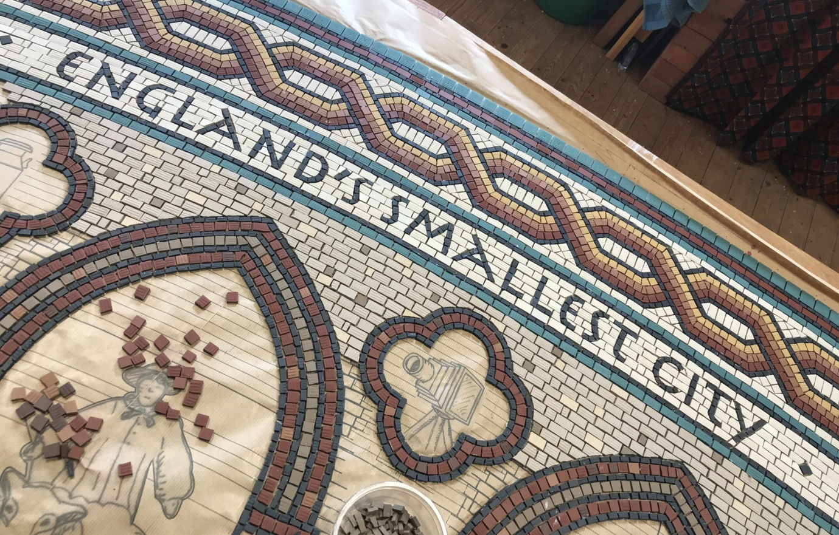

Visitors £3.50, we will be happy to see you
For more details contact Sue 870618

