The Westbury Sub Mendip
Scarecrow Competition

It’s time to build those scarecrows
Design your scarecrow with a “traffic calming” theme
Entry forms and competition rules will be available from the village shop and website (https://westburysubmendip-pc.gov.uk)
Scarecrows will be positioned around the village to encourage safe driving
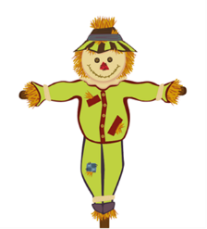
Take your scarecrow to Court House by 19th July where judging will take place

