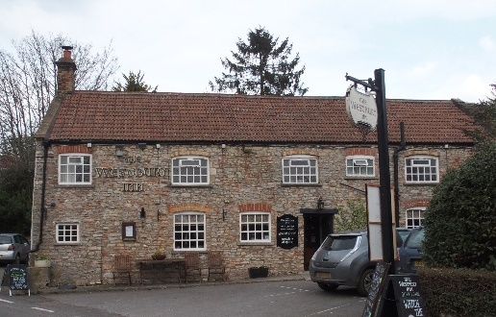

01749 870402
TAKEAWAY MENU Wed.-Sat.12-2pm & 5.00-8.00pm and Sundays 12 ‘til 2.30pm.
**Menu from 12th to 16th May **
Order day before advised but try last minute orders.
Self-collection via 10 minute time slots but must stay outside the Pub.
Delivery can be arranged for £2.50 Westbury, Easton, Rodney and Draycott. Cheddar £3.50. Over 70s, living in Westbury-sub-Mendip, free.

STARTERS **************************
Prawn cocktail with crispy iceberg and Marie Rose sauce £6.50
Patatas bravas (sautéed potatoes, chorizo and chilli) £5
Cod goujons with roasted tomato sauce £5

MAINS **************************
Chicken breast with white, cream, leek and mushroom sauce, veg & pots £11.50
Deep filled shortcrust pie of day (please ask variety) with veg & pots £11.50
Beer battered cod, chips and peas £10
Beef lasagne with salad and garlic bread £10
Wholetail scampi with chips, peas and tartare sauce £10
Curry of the Day with rice and accompaniments £10
Ratatouille and stilton gratin with mixed salad £10
Fish pie topped with cheesy mash, peas and crusty bread £10
Beef steak burger in brioche bun with salad and chips £10
Add cheese £1.50 Add bacon £1.50

See next page for Flatbreads,
Desserts and Sunday roasts.

FLATBREADS
Sweet chilli chicken and bacon £9
Pesto, pepper, tomato and feta £7.50
Served with salad and coleslaw

DESSERTS ************************** each £5.00

Sticky toffee pudding with caramel sauce or
Warm chocolate brownie, or Cheesecake (please ask for variety) or
Panna cotta (please ask for variety)

************

SUNDAY TRADITIONAL ROASTS from 12 ‘til 2.30pm only

Beef, lamb, chicken or pork £12.50
Poached salmon with lemon and caper dressing £12.50

************************************************************
BEER, CIDER, LAGER 4pts from £10.00

***********************************************

DELIVERY CHARGES
Over 70s living in Westbury-sub-Mendip free.

£2.50 to Westbury-sub-Mendip, Easton, Rodney Stoke
& Draycott
£3.50 to Cheddar

01749 870402

