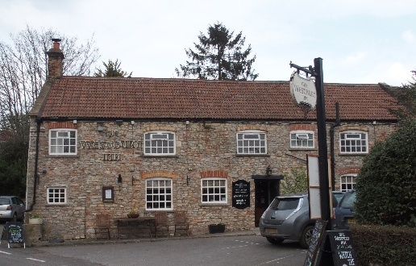

01749 870402
TAKEAWAY MENU Wed.-Sat.12-2pm & 5.00-8.00pm and Sundays 12 ‘til 2.30pm.
**Menu 7th to 11th April **
Order day before advised but try last minute orders.
Self-collection via 10 minute time slots but must stay outside the Pub.
Delivery can be arranged for £2.50 Westbury, Easton, Rodney and Draycott. Cheddar £3.50. Over 70s, living in Westbury-sub-Mendip, free.

STARTERS **************************
Carrot & quinoa cakes with sauerkraut salad £4
Spice cauliflower cheese soup with crusty bread £4
Chicken liver pate with red onion marmalade and toast £4
Salt & pepper peanut coated calamari with sweet chilli dip £5

MAINS **************************
Darne of salmon with lemon and black pepper butter, veg & pots £12
BBQ pulled pork Wellington with light gravy, veg & pots £10
Beer battered cod, chips and peas £10
Beef lasagne with salad and garlic bread £10
Wholetail scampi with chips, peas and tartare sauce £10
Roasted butternut squash and spinach Bhuna with rice,
poppadum and mango chutney £10
Liver and bacon with onion gravy, mash and peas £10
Chicken tikka masala with rice poppadum and mango chutney £10
Hearty beef stew with herb dumpling and vegetables £10

See next page for Pizzas, Desserts and Sunday roasts.

SOURDOUGH PIZZA 9’’ £10 or 12’’ £12.50
Mushroom, salami & truffle oil or Chorizo, chilli & red onion or Classic Margherita or Tuna, anchovy, garlic & black olive

DESSERTS ************************** each £5.00

Sticky toffee pudding with caramel sauce or
Chocolate Marquise or Lemon & lime Panna cotta

************

SUNDAY TRADITIONAL ROASTS from 12 ‘til 2.30pm only

Beef, lamb, chicken or pork £12.50
Poached salmon with lemon Hollandaise sauce £12.50

************************************************************
Available for delivery only BEER, CIDER, LAGER 4pts from £10.00

***********************************************

DELIVERY CHARGES
Over 70s living in Westbury-sub-Mendip free.

£2.50 to Westbury-sub-Mendip, Easton, Rodney Stoke
& Draycott
£3.50 to Cheddar

01749 870402

