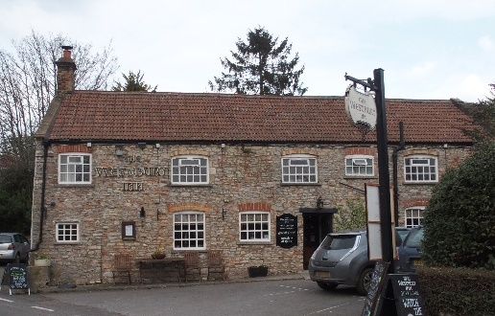

01749 870402
TAKEAWAY MENU Wed.-Sat.12-2pm & 5.00-8.00pm and Sundays 12 ‘til 2.30pm.
**Menu 31st March – 4th April **
Order day before advised but try last minute orders.
Self-collection via 10 minute time slots but must stay outside the Pub.
Delivery can be arranged for £2.50 Westbury, Easton, Rodney and Draycott. Cheddar £3.50. Over 70s, living in Westbury-sub-Mendip, free.

STARTERS **************************
Smoked cod fishcakes with tartare sauce £5
Buttermilk chicken fillets with leeks and lemon chilli butter £5
Tomato and hummus crostini £4

MAINS **************************
Monkfish wrapped in Parma ham with Provencal sauce, veg & pots £12.50
Lamb bhuna with poppadum and mango chutney £10
Beer battered cod, chips and peas £10
Beef lasagne with salad and garlic bread £10
Wholetail scampi with chips, peas and tartare sauce £10
Pan seared chicken breast with a mustard and horseradish cream sauce, veg & pots £10
Deep filled steak and stilton shortcrust pie with veg & pots £11.50
Pork, parsnip and cider cobble with veg & pots £10
Vegetable bhuna with poppadum and mango chutney £10

See next page for Pizzas and Desserts.

SOURDOUGH PIZZA 9’’ £10 or 12’’ £12.50
Mushroom, salami & truffle oil or Chorizo, chilli & red onion or Classic Margherita or Tuna, anchovy, garlic & black olive

DESSERTS ************************** each £5.00

Warm Banana cake with vanilla ice cream or
Chocolate Marquise or Apple & rhubarb crumble

************

SUNDAY TRADITIONAL ROASTS from 12 ‘til 2.30pm only

Beef, lamb, chicken or pork £12.50
Poached salmon with lemon Hollandaise sauce £12.50

************************************************************
Available for delivery only BEER, CIDER, LAGER 4pts from £10.00

***********************************************

DELIVERY CHARGES
Over 70s living in Westbury-sub-Mendip free.

£2.50 to Westbury-sub-Mendip, Easton, Rodney Stoke
& Draycott
£3.50 to Cheddar

01749 870402

