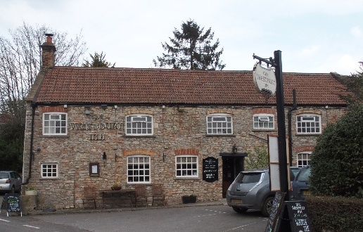

01749 870402
TAKEAWAY MENU Wed.-Sat.12-2pm & 5.00-8.00pm and Sundays 12 ‘til 2.30pm.
**Menu 3rd – 7th March **
Order day before advised but try last minute orders.
Self-collection via 10 minute time slots but must stay outside the Pub.
Delivery can be arranged for £2.50 Westbury, Easton, Rodney and Draycott. Cheddar £3.50. Over 70s, living in Westbury-sub-Mendip, free.

STARTERS **************************
Onion Bhajis with salad and raita dip £5
Devilled whitebait with garlic mayonnaise £5
Chorizo and stilton stuffed mushrooms £5
Pea and Halloumi fritters with salad £5

MAINS **************************
Pan fried Barbary duck breast with plum sauce, veg & pots £12.50
Shortcrust deep filled chicken,leek and ham pie with gravy,veg & pots£11.50
Mixed bean and quorn enchiladas with Provençal sauce, salad and coleslaw £10
Beer battered cod, chips and peas £10
Beef lasagne with salad and garlic bread £10
Wholetail scampi with chips, peas and tartare sauce £10
Fresh cod and salmon bake topped with mashed potato served
with peas& crusty bread £12.50
8ozs Steak burger in a brioche bun with chips, salad and coleslaw £10
ADD cheese £1.50 or bacon £1.50
Braised Belly pork with cider gravy, potatoes & veg £12

See next page for Pizzas and Desserts.
SOURDOUGH PIZZA 9’’ £10 or 12’’ £12.50
Mushroom, salami & truffle oil or Chorizo, chilli & red onion or Classic Margherita or Tuna, anchovy, garlic & black olive

DESSERTS ************************** each £5.00

Twix cheesecake with toffee sauce or Chocolate brownie with chocolate sauce or Sticky toffee pudding or Chocolate orange torte

************

Sunday roasts from 12.00 ‘til 2.30pm.

SUNDAY TRADITIONAL ROASTS
Beef, lamb, chicken or pork £12.50
Poached salmon with lemon Hollandaise sauce £12.50

************************************************************
Available for delivery only BEER, CIDER, LAGER 4pts from £10.00

***********************************************

DELIVERY CHARGES
Over 70s living in Westbury-sub-Mendip free.

£2.50 to Westbury-sub-Mendip, Easton, Rodney Stoke
& Draycott
£3.50 to Cheddar

01749 870402

