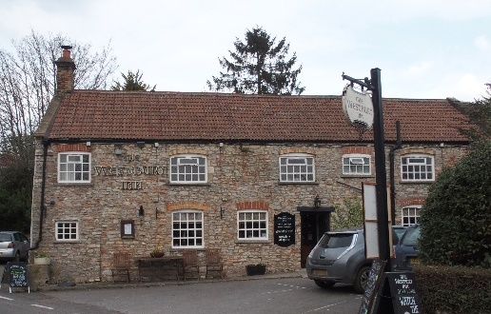

01749 870402
TAKEAWAY MENU Wed.-Sat.12-2pm & 5.00-8.00pm and Sundays 12 ‘til 2.30pm.
**Menu 24th – 28th March **
Order day before advised but try last minute orders.
Self-collection via 10 minute time slots but must stay outside the Pub.
Delivery can be arranged for £2.50 Westbury, Easton, Rodney and Draycott. Cheddar £3.50. Over 70s, living in Westbury-sub-Mendip, free.

STARTERS **************************
Smoked cod fishcakes with tartare sauce £5
Chicken liver pate with red onion marmalade and toast £4.50
Tempura cauliflower florets with stilton mayo £4

MAINS **************************
Coronation chicken salad £10
Duo of pork (slow cooked belly pork and pulled pork) with
BBQ Bourbon gravy, veg & pots £12
Beer battered cod, chips and peas £10
Beef lasagne with salad and garlic bread £10
Wholetail scampi with chips, peas and tartare sauce £10
Deep filled chicken, chorizo & mushroom shortcrust pastry pie
with veg & pots £10
Halloumi burger with red onion jam in a brioche bun, salad, chips & coleslaw £10
Baked piri piri cod with crushed new pots & red pepper sauce & veg £12
Beef & mushroom stroganoff with herby tagliatelle £10
Pork tenderloin with apple sauerkraut and sweet onion sauce, veg & pots £12.50
Chinese style chicken curry with rice and prawn crackers £10
Salmon fillet with prawn and white wine cream sauce £12.50
See next page for Pizzas and Desserts.
SOURDOUGH PIZZA 9’’ £10 or 12’’ £12.50
Mushroom, salami & truffle oil or Chorizo, chilli & red onion or Classic Margherita or Tuna, anchovy, garlic & black olive

DESSERTS ************************** each £5.00

Banana cake with vanilla ice cream or Chocolate brownie with chocolate sauce
or Peanut brittle cheesecake or Sticky toffee pudding with caramel sauce

************

SUNDAY TRADITIONAL ROASTS from 12 ‘til 2.30pm only

Beef, lamb, chicken or pork £12.50
Poached salmon with lemon Hollandaise sauce £12.50

************************************************************
Available for delivery only BEER, CIDER, LAGER 4pts from £10.00

***********************************************

DELIVERY CHARGES
Over 70s living in Westbury-sub-Mendip free.

£2.50 to Westbury-sub-Mendip, Easton, Rodney Stoke
& Draycott
£3.50 to Cheddar

01749 870402

