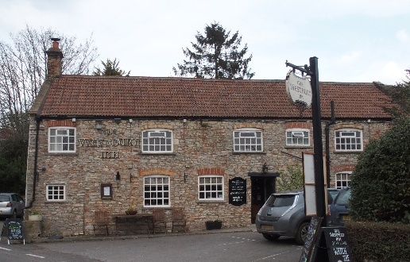

01749 870402
TAKEAWAY MENU Wed.-Sat.12-2pm & 5.00-8.00pm and Sundays 12 ‘til 2.30pm.
**Menu 10th – 14th March **
Order day before advised but try last minute orders.
Self-collection via 10 minute time slots but must stay outside the Pub.
Delivery can be arranged for £2.50 Westbury, Easton, Rodney and Draycott. Cheddar £3.50. Over 70s, living in Westbury-sub-Mendip, free.

STARTERS **************************
Homemade Bantam scotch egg with piccalilli £5
Smoked mackerel pate with horseradish mayo and toast £4
Pan fried halloumi with chilli jam £4.50
Avocado and stilton gratin £5
Creamy garlic mushrooms £5

MAINS **************************
Lamb wellington (slow cooked pulled lamb in pastry) with rosemary and redcurrant gravy, veg & pots £12.50
Pork chop topped with melted stilton with apple cider gravy, veg & pots £12.50
Beer battered cod, chips and peas £10
Beef lasagne with salad and garlic bread £10
Wholetail scampi with chips, peas and tartare sauce £10
Chicken teriyaki with rice £10
Beetroot and red onion tarte tatin with veg & pots £10
Crab & prawn linguini with salad £12
Warm gammon ham with parsley sauce, veg & pots £10
Deep filled steak, Guinness and mushroom shortcrust pastry pie
with gravy,veg & pots £12.50
See next page for Pizzas and Desserts.
SOURDOUGH PIZZA 9’’ £10 or 12’’ £12.50
Mushroom, salami & truffle oil or Chorizo, chilli & red onion or Classic Margherita or Tuna, anchovy, garlic & black olive

DESSERTS ************************** each £5.00

Chocolate brownie with chocolate sauce or Lemon and lime cheesecake or
Sticky toffee pudding or Chocolate orange torte or
Vanilla panna cotta with mixed berry compote

************
Starters from overleaf

SUNDAY TRADITIONAL ROASTS

Beef (topside or overnight cooked brisket), lamb, chicken or Loin of pork £12.50
Poached salmon with lemon Hollandaise sauce £12.50

Desserts from overleaf

Served 12noon ‘til 2.30pm

************************************************************
Available for delivery only BEER, CIDER, LAGER 4pts from £10.00

***********************************************

DELIVERY CHARGES
Over 70s living in Westbury-sub-Mendip free.

£2.50 to Westbury-sub-Mendip, Easton, Rodney Stoke
& Draycott
£3.50 to Cheddar
01749 870402

