8th February 2021
Dear All,
I’m sure many of you will have picked up on the shenanigans at a certain parish council meeting in Cheshire. I am sorry, or maybe not, to inform you that Westbury’s parish council meetings are somewhat less combustible. Your councillors all seem to get on with one another, are admirably served by our clerk and actually do get some useful business done. Members of the public are welcome to observe our meetings at any time – just contact our clerk, contacts on our website or in the back of The Pew, but I cannot promise any fireworks! You can also read our minutes on the website and village noticeboards
My last letter mentioning dark skies prompted more responses than usual. It is over ten years since the council adopted a dark skies policy. At our last meeting on 3 Feb, we discussed what more might be done. Councillor John Millbank, who lives on the Lodge Hill estate, made an informal survey of current residents’ opinions on street lighting. The current lights on Lodge Hill and Farm Close are switched off between midnight and 6am, but although some residents would like them turned off altogether, more would prefer them to remain. They are open, however, to a lower lighting level so we will be pursuing this matter with Somerset County Council. We also looked at other sources of light pollution in the village and will be writing to a number of larger property owners to see what amelioration measures might be possible. I ask again for parishioners to let me know about any lighting they find intrusive in the village.
It would be good to know how dark we are managing to keep our village. A fun way to find out is to take part in the Campaign for Protection of Rural England’s (CPRE) annual star count. From now until 14 Feb all you need to do is find a clear night and the constellation Orion. Count the number of stars you can see with the naked eye in it, then report it to CPRE and to us via my email. There is an induction pack which makes it all simple. Just Google CPRE star count or try this link
Help us revisit our dark skies policy and gain more knowledge of the wonders of the universe.

Continue to stay safe,

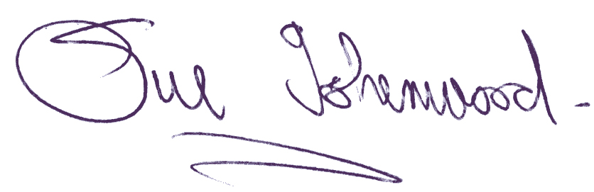
Sue Isherwood, Chair Westbury-sub-Mendip Parish Council sueisherwood9@gmail.com 01749 870457

