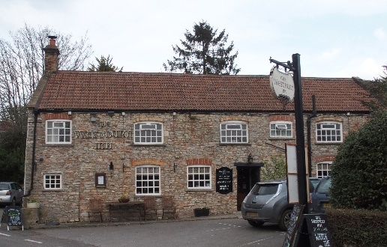

01749 870402
TAKEAWAY MENU Wed.-Sat.12-2pm & 5.00-8.00pm and Sundays 12 ‘til 2.30pm.
**Menu 24th to 28th February **
Order day before advised but try last minute orders.
Self-collection via 10 minute time slots but must stay outside the Pub.
Delivery can be arranged for £2.50 Westbury, Easton, Rodney and Draycott. Cheddar £3.50. Over 70s, living in Westbury-sub-Mendip, free.

STARTERS **************************
Shell on king prawns Mexicana (chilli, garlic, tomatoes & peppers) £6
Stuffed button mushrooms with liver pate, cooked in garlic butter £5.50
Onion Bahjis with raita dip £5
Grilled goats cheese and tomato bruschetta £5

MAINS **************************
Stuffed chicken breast with sun dried tomato, basil and white wine cream sauce£12.50
Beer battered cod, chips and peas £10
Beef lasagne with salad and garlic bread £10
Wholetail scampi with chips, peas and tartare sauce £10
Braised lambs liver, crispy bacon, onion gravy, mash & veg £10
Minced steak, potato and onion pie with gravy, potatoes & veg £12.50
Thai red curry with butternut squash, tender stem broccoli, rice and prawn crackers £11
Grilled gammon and pineapple with chips and peas £10
Chinese style pulled Lamb and beansprouts with rice £12.50
Cajun salmon and king prawns with ground cumin cream, potatoes & veg £12.50

SOURDOUGH PIZZA 9’’ £10 or 12’’ £12.50
Mushroom, salami & truffle oil or Chorizo, chilli & red onion or Classic Margherita or Tuna, anchovy, garlic & black olive

DESSERTS ************************** each £5.00

Lemon meringue pie or Chocolate brownie with clotted cream or
Sticky toffee pudding or Twix cheesecake with toffee sauce

************

Sunday roasts from 12.00 ‘til 2.30pm.

SUNDAY TRADITIONAL ROASTS
Beef, lamb, chicken or pork £12.50
Poached salmon with lemon Hollandaise sauce £12.50

************************************************************
Available for delivery only BEER, CIDER, LAGER 4pts from £10.00

***********************************************

DELIVERY CHARGES
Over 70s living in Westbury-sub-Mendip free.

£2.50 to Westbury-sub-Mendip, Easton, Rodney Stoke
& Draycott
£3.50 to Cheddar

01749 870402

