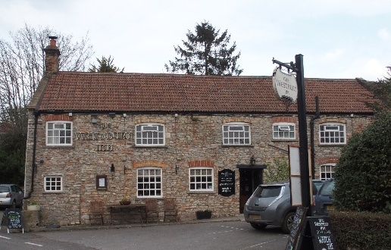

01749 870402
TAKEAWAY MENU Wed.-Sat.12-2pm & 5.00-8.00pm and Sundays 12 ‘til 2.30pm.
**Menu 17th to 21st February **
Order day before advised but try last minute orders.
Self-collection via 10 minute time slots but must stay outside the Pub.
Delivery can be arranged for £2.50 Westbury, Easton, Rodney and Draycott. Cheddar £3.50. Over 70s, living in Westbury-sub-Mendip, free.

STARTERS **************************
Chicken liver pate with red onion marmalade and toast £5
Carrot and quinoa cakes with coriander mayo £5
Crispy salt and pepper calamari with sweet chilli dip £5.50
Deep fried breaded camembert with cranberry compote £5.50

MAINS **************************
Steak & kidney shortcrust pastry pie or Turkey, leek & ham shortcrust pastry pie with veg & pots £11.50
Quarter crispy duck with Chinese BBQ sauce, beansprouts and egg noodles £12.50
Beer battered cod, chips and peas £10
Chicken and broccoli lasagne with salad and garlic bread £10
Wholetail scampi with chips, peas and tartare sauce £10
Flaked cod and king prawn Veronique Gratin (white wine cream and grape sauce) with salad and crusty bread £12.50
Butter chicken curry with rice and poppadum £10
Pork and cider hot pot with fresh vegetables £10
Cottage pie topped with creamy mash, peas, crusty bread and gravy £10
Sweet and sour King prawns with rice and prawn crackers £12.50

PTO for Friday and Saturday night specials *****

FRIDAY NIGHT SPECIAL
8ozs Rib Eye Steak with the traditional trimmings and chips £15
ADD Pepper sauce £2.00

SATURDAY NIGHT SPECIAL
Braised Monkfish Provencal with green veg and saffron rice £15

LIMITED AVAILIBILTY FOR BOTH EVENINGS

DESSERTS ************************** each £5.00

Apple and blueberry crumble or Chocolate brownie or
Sticky toffee pudding or Raspberry & clotted cream cheesecake

************

Sunday roasts from 12.00 ‘til 2.30pm.

SUNDAY TRADITIONAL ROASTS
Beef, lamb, chicken or pork £12.50
Poached salmon with lemon Hollandaise sauce £12.50

************************************************************
Available for delivery only BEER, CIDER, LAGER 4pts from £10.00

***********************************************

DELIVERY CHARGES
Over 70s living in Westbury-sub-Mendip free.

£2.50 to Westbury-sub-Mendip, Easton, Rodney Stoke
& Draycott
£3.50 to Cheddar

01749 870402

