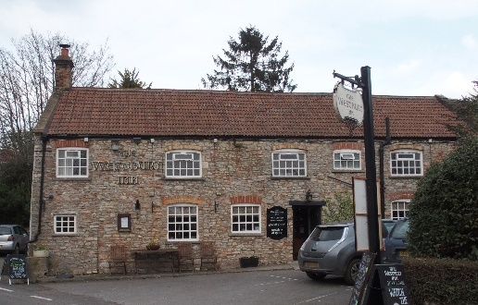

01749 870402
TAKEAWAY MENU Wed.-Sat.12-2pm & 5.00-8.00pm and Sundays 12 ‘til 2.30pm.
**Menu 10th to 14th February **
Order day before advised but try last minute orders.
Self-collection via 10 minute time slots but must stay outside the Pub.
Delivery can be arranged for £2.50 Westbury, Easton, Rodney and Draycott. Cheddar £3.50. Over 70s, living in Westbury-sub-Mendip, free.

STARTERS **************************
Vegetable spring roll with sweet chilli dip £4
Pork and apple Bhajis with piccalilli £5
Salmon and dill fishcakes with tartare sauce £5
Avocado and Stilton gratin £5.50

MAINS **************************
Steak and kidney shortcrust pastry pie with veg & pots £11.50
Quarter slow roasted duck with rich orange gravy veg & pots £12.50
Beer battered cod, chips and peas £10
Beef lasagne with salad and garlic bread £10
Wholetail scampi with chips, peas and tartare sauce £10
Breast of chicken Kiev with chips and salad £12
Sweet and sour King prawns with rice and prawn crackers £12.50
Butternut squash and spinach risotto with red pepper salsa and mixed salad £10
Chicken korma with rice, poppadum and mango chutney £10
8ozs minced steak burger, brioche bun chips and coleslaw £12.50
ADD cheese £1.50 Bacon £1.50

SOURDOUGH PIZZA 9’’ £10.00 or 12’’ £12.50
Mushroom, salami & truffle oil or Chorizo, chilli & red onion or Classic Margherita or Tuna, anchovy, garlic & black olive PTO

DESSERTS ************************** each £5.00

Banana and toffee crumble or Chocolate brownie or
Sticky toffee pudding or Pineapple and Malibu cheesecake

Sunday roasts from 12.00 ‘til 2.30pm.

SUNDAY TRADITIONAL ROASTS
Beef, lamb, chicken or pork £12.50
Poached salmon with lemon Hollandaise sauce £12.50

Available for delivery only BEER, CIDER, LAGER 4pts from £10.00
********************************
TREAT YOUR LOVED ONE
To our
Valentines Menu
12th and 13th February (evenings only)
Menu attached, phone in your order.

Two 3 Course meals – one off menu
£35
(One 3 Course meal £17.50)
*************************************************************
DELIVERY CHARGES
Over 70s living in Westbury-sub-Mendip free.

£2.50 to Westbury-sub-Mendip, Easton, Rodney Stoke
& Draycott
£3.50 to Cheddar
01749 870402

