18th January 2021
Dear All,
Well, we’re back into the dark days of January and full lockdown. I know what a law abiding community we are here in Westbury, so I don’t need to remind you how important it is to keep to the government guidelines. The roll out of vaccinations will not be sufficient to protect all of us for several more months. This third lockdown comes hard and stress levels are inevitably rising. Remember that we have village specific help lines and that both Mendip District and Somerset County Councils are also offering support.
Something that brightened our lives over Christmas were the colourful lighting displays on many houses around the village. But now they are taken down we still have the night sky to delight us. The new moon has been very striking this week. We are lucky here to be able to see so many stars.
Over ten years ago now the Parish Council adopted a dark skies policy and put out a whole village survey to seek local opinion, particularly about turning off street lights. The results were overwhelmingly in favour of switching them off everywhere except the Lodge Hill estate and Stoneleigh where they remain in place. Many of you who have moved into the village since that time might not be so aware that this policy exists and informs council recommendations on new planning proposals.
The Mendip AONB and Mendip District Council also have dark skies policies and we are all keen to remind villagers that these policies allow you to enjoy the more than one thousand stars you can see from here on a clear night. (City dwellers can see barely one hundred.)
One thing we can all do to contribute is to check our own outside lighting. This can often have oversensitive movement sensors which are triggered when anyone passes on the road without entering the property. Light spillage can also be a problem as lights need only to shine downwards, not outwards. We often don’t notice how our outside lights actually work – from the outside of our homes. Do to check if they maximise our dark skies status, so contributing to protecting our climate and making savings on your electricity bills.
Continue to stay safe,

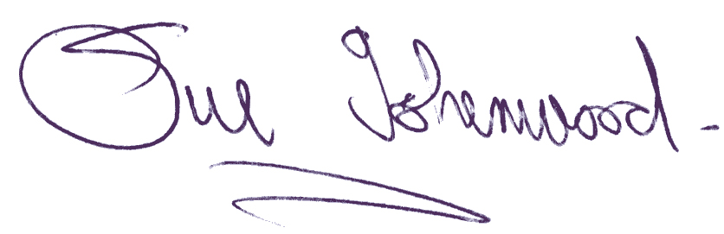
Sue Isherwood, Chair Westbury-sub-Mendip Parish Council sueisherwood9@gmail.com 01749 870457

