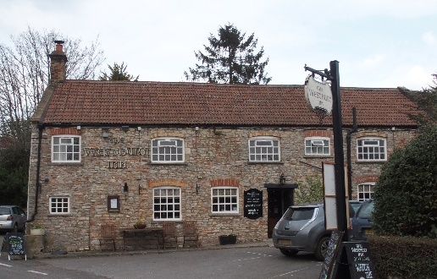

01749 870402
TAKEAWAY MENU Wed.-Sat.12-2pm & 5.00-8.00pm and Sundays 12 ‘til 2.30pm.
**Menu 27th to 31st January **
Order day before advised but try last minute orders.
Self-collection via 10 minute time slots but must stay outside the Pub.
Delivery can be arranged for £2.50 Westbury, Easton, Rodney and Draycott. Cheddar £3.50. Over 70s, living in Westbury-sub-Mendip, free.

STARTERS **************************
Ham and goose terrine with red onion marmalade and toast £4
Crispy Chinese style duck with cucumber, spring onion and Hoisin sauce £7
Salmon and dill fishcakes with tartare sauce £5
Creamy garlic mushrooms flamed in brandy £4
Prawn cocktail with Marie Rose sauce £5

MAINS **************************
Steak pie OR turkey, ham and leek pie with veg & pots £10
Quarter slow roasted duck with rich orange gravy veg & pots £12.50
Beer battered cod, chips and peas £10
Beef lasagne with salad and garlic bread £10
Wholetail scampi with chips, peas and tartare sauce £10
Chicken pasanda with rice and poppadum £10
Fillet of cod and potato gratin with vegetables £10
Moroccan lamb tagine with cous cous £12
Roasted butternut squash and mixed vegetable risotto with mixed salad £10
Hearty beef stew with suet dumplings and crusty bread £12

SOURDOUGH PIZZA 9’’ £10.00 or 12’’ £12.50
Mushroom, salami & truffle oil or Chorizo, chilli & red onion or Classic Margherita or Tuna, anchovy, garlic & black olive

DESSERTS ************************** each £5.00

Marmalade and whisky bread and butter pudding or Chocolate brownie or
Sticky toffee pudding or Lemon and lime panna cotta

Sunday roasts from 12.00 ‘til 2.30pm.

SUNDAY TRADITIONAL ROASTS
Beef, lamb, chicken or pork £12.50
Poached salmon with lemon Hollandaise sauce £12.50

Available for delivery only BEER, CIDER, LAGER 4pts from £10.00
********************************
Heads up..
TREAT YOUR LOVED ONE
To our
Valentines Menu
12th and 13th February (evenings only)
Menu to follow.

Two 3 Course meals – one off menu
£35
*************************************************************
DELIVERY CHARGES
Over 70s living in Westbury-sub-Mendip free.

£2.50 to Westbury-sub-Mendip, Easton, Rodney Stoke
& Draycott
£3.50 to Cheddar
01749 870402

