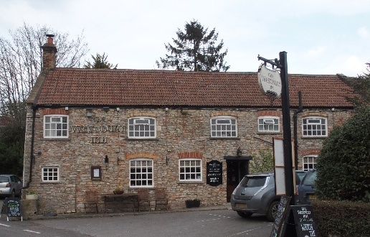

01749 870402
TAKEAWAY MENU Wed.-Sat.12-2pm & 5.00-8.00pm and Sundays 12 ‘til 2.30pm.
**Menu 20th to 24th January **
Order day before advised but try last minute orders.
Self-collection via 10 minute time slots but must stay outside the Pub.
Delivery can be arranged for £2.50 Westbury, Easton, Rodney and Draycott. Cheddar £3.50. Over 70s, living in Westbury-sub-Mendip, free.

STARTERS **************************
Chinese chicken spring roll with Hoisin dip £5
Deep fried breaded brie with cranberry compote £5
Ham and goose terrine with red onion marmalade and toast £4
Szechuan chicken skewers £4
Creamy garlic mushrooms flamed in brandy £4
Prawn cocktail with Marie Rose sauce £5

MAINS **************************
Partridge & pheasant pie OR turkey, ham and leek pie with veg & pots £10
Quarter slow roasted duck with rich orange gravy veg & pots £12.50
Green Thai salmon curry with rice and prawn crackers £12.50
Beer battered cod, chips and peas £10
Beef lasagne with salad and garlic bread £10
Wholetail scampi with chips, peas and tartare sauce £10
Haggis, neeps and tatties £10
Chicken tikka masala with rice, poppadum and mango chutney £10
Cottage pie with peas and crusty bread £10
Green Thai vegetable curry with rice and prawn crackers £10
Pork and mushroom stroganoff with rice £10

SOURDOUGH PIZZA 9’’ £10.00 or 12’’ £12.50
Mushroom, salami & truffle oil or Chorizo, chilli & red onion or Classic Margherita or Tuna, anchovy, garlic & black olive

DESSERTS ************************** each £5.00

Warm Blackberry tart or Chocolate brownie or Sticky toffee pudding or
Homemade Marshmallow fondue with warm dark chocolate sauce and butterscotch sauce

Sunday roasts from 12.00 ‘til 2.30pm.

SUNDAY TRADITIONAL ROASTS
Beef, lamb, or pork £12.50
Poached salmon with lemon Hollandaise sauce £12.50

BEER, CIDER, LAGER 4pts from £10.00

DELIVERY CHARGES
Over 70s living in Westbury-sub-Mendip free.

£2.50 to Westbury-sub-Mendip, Easton, Rodney Stoke
& Draycott
£3.50 to Cheddar

01749 870402

