21st December 2020
Dear All,

I want to say a big thank you to everyone in Westbury for pulling together and being such responsible and caring people. It’s been a strange and tough year and we’ve clearly got some difficult times still ahead of us this winter, but I believe our community spirit will survive to see better times.
I’d particularly like to thank Sue Reece and Mick Fletcher for initiating our regular updates and for coordinating a wide range of village support systems. I’d also like to thank all the volunteers who are still staffing our helplines, working in the shop, doing shopping deliveries for those who need to shelter and keeping their eyes and ears open for anyone who might need assistance.
Andy in the pub is keeping us all going with excellent takeaways and great eating in house too. I had a brilliant lunch there today with my social support bubble. The Friendly Society has made funds available to respond to several cases of hardship caused by Covid 19 and the church has quietly kept our spirits up, particularly working with the shop to set up with the Nativity scene - thank you Malcolm Harding and team.
A final thought now for those whose plans for Christmas have had to change in the last few days. Does this affect you or any of your neighbours? There might be people now unexpectedly on their own on Christmas Day, or those who have run their larders down, expecting to be away. We can’t invite neighbours to join us at a table, but there are many other ways in which we could support them and help make their Xmas special.
It is still not too late to ask the village shop what they can supply and deliver (email westburyshoporders@gmail.com ) We are still offering a supermarket shopping service (email burrowsncb@aol.com ) and if you know of anyone you think might be in need, just let us know.
Let’s all make sure that we continue to look out for one another, this year more than ever.
Happy Christmas and New Year and stay safe.

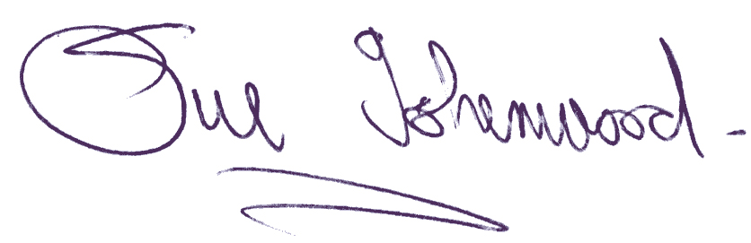
Sue Isherwood, Chair Westbury-sub-Mendip Parish Council sueisherwood9@gmail.com 01749 870457

