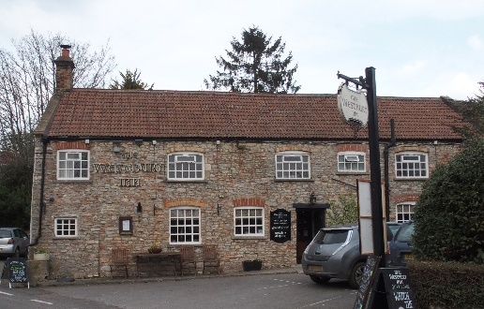

01749 870402
TAKEAWAY MENU Thur.-Sat.12-2pm & 5.00-8.00pm and Sunday 12 ‘til 2.30pm.
**Menu 9th- 13th December **
Order day before advised but try last minute orders.
Self-collection via 10 minute time slots but must stay outside the Pub.
Delivery can be arranged for £2.50 Westbury, Easton, Rodney and Draycott. Cheddar £3.50. Over 70s, living in Westbury-sub-Mendip, free.

STARTERS **************************
Chicken spring roll with sweet chilli dip £5.00
Breaded deep fried brie with cranberry compote £5.00
Smoked mackerel pate, crusty bread £4.00
Cream of carrot and coriander soup, crusty bread £4.00

MAINS **************************
Beer battered cod, chips and peas £10.00
Pheasant, leek and ham pie with veg and pots £12.00
Beef lasagne with salad and garlic bread £10.00
Wholetail scampi with chips peas and tartare sauce £10.00
Spinach and ricotta cannelloni, salad & garlic bread £10.00
Chinese style shrimp curry with rice and prawn crackers £12.00
Breast of chicken Kiev with salad and chips £10.00
Braised steak, rich red wine gravy, veg and pots. £12.00
Lamb Wellington with rosemary and redcurrant gravy, potatoes and veg. £12.00

SOURDOUGH PIZZA 9’’ £10.00 or 12’’ £12.50
Mushroom, salami & truffle oil or Chorizo, chilli & red onion or Classic Margherita or Tuna, anchovy, garlic & black olive.

PTO for Friday night special Main, Desserts and Sunday menu.

FRIDAY NIGHT SPECIAL MAIN:
Sirloin steak with tomatoes, onions, mushroom, peas and chips £15.00

DESSERTS ************************** each £5.00

Chocolate brownie or Sticky toffee pudding or
Chef’s choice of Homemade cheesecake or Homemade Marshmallow Fondue with butterscotch and dark chocolate sauce
Please ask for Chef’s choice of flavour of above desserts

Sunday roasts from 12.00 ‘til 2.30pm.

SUNDAY TRADITIONAL ROASTS
Roast turkey, chipolatas, bacon rolls, stuffing £15.00
Beef, lamb, or pork £12.50
Poached salmon with lemon Hollandaise sauce £12.50

BEER, CIDER, LAGER 4pts from £10.00

DELIVERY CHARGES
Over 70s living in Westbury-sub-Mendip free.

£2.50 to Westbury-sub-Mendip, Easton, Rodney Stoke
& Draycott
£3.50 to Cheddar

01749 870402

