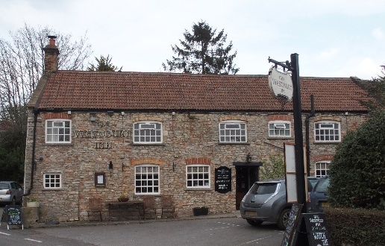

01749 870402
7th December 2020 Update.
Dear All,
Andy, is recovering quickly and has had his 10 days of quarantine following onset of symptoms (23rd November), by 4th December. The same applies to the chef, Matt, who was positive but symptomless at the same time. Ann-Marie and Adam have had three tests each during this time and have been negative each time. This means that they will have done their 2 weeks quarantining, which is necessary because they have been in contact with a case, by 8th December. The Pub will have been formally anti-COVID-19 fogged on Monday 7th December.

The Pub will be safe to re-open on Wednesday 9th December. The Restaurant will be opened to take bookings from Wednesday evening, 9th December – remember that such bookings can only be for members of one household. Takeaways will also start on that Wednesday evening and be available until the end of Sunday lunch. It is expected that this Wednesday to Sunday Takeaway pattern will continue for the foreseeable future. The Restaurant and Takeaway Menus will be renewed each week as before. The restaurant will then continue to be open for lunch and dinner at least until Wednesday 16th December. On that day there is a Government review of the Tiers when changes could be possible – who knows? Tier 2 is particularly awkward for the Pub as in Tier 3 the restaurant would be shut but the Takeaway would continue whilst being supported by the Government with a grant. In Tier 1 we, the Pub, can have 6 people from different households dining
or coming into the pub for a social and socially distanced drinks. In Tier 2 it is only members of one household that can come to the Pub for a ‘meal and drinks’ and there is no grant support.
For the Pub it seems inevitable that over Christmas and New Year the guidelines are not going to change significantly so that trade over this period will continue to be small. Without considerable Village support things will get increasingly difficult for the Pub going into the New Year.

Andy would like to record his thanks to the many who sent emails and letters of support while he was really poorly with this virus.
Take care. Andy Jones and Ann-Marie.

