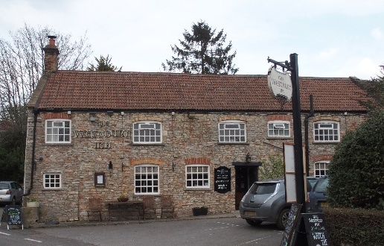

01749 870402
TAKEAWAY MENU Wed.-Sat.12-2pm & 5.00-8.00pm and Sunday 12 ‘til 2.30pm.
**Menu 23rd December – 3rd January **
Order day before advised but try last minute orders.
Self-collection via 10 minute time slots but must stay outside the Pub.
Delivery can be arranged for £2.50 Westbury, Easton, Rodney and Draycott. Cheddar £3.50. Over 70s, living in Westbury-sub-Mendip, free.

STARTERS **************************
Homemade soup of the day and crusty bread £4.00
Smoked mackerel pate with horseradish may and toast £4.00
Chinese chicken spring roll with Hoisin dip £5.00
Deep fried breaded brie with cranberry compote £5.00
Buttermilk Cajun chicken strips with sweet chilli dip £4.50

MAINS **************************
Turkey escalope with leek, mushroom and white wine cream sauce served with veg & pots £12.50
Steak and bacon shortcrust pastry pie with veg and pots £10.00
Chicken Dansak with rice, poppadum an mango chutney £10.00
Hazelnut and cranberry wellington with mushroom sherry sauce.
Served with veg and pots £10.00
Quarter slow roasted duck with rich orange gravy veg & pots £12.50
Sweet and sour King prawn with rice and prawn crackers £12.50
Beer battered cod, chips and peas £10.00
Beef lasagne with salad and garlic bread £10.00
Wholetail scampi with chips, peas and tartare sauce £10.00
Chinese style pork curry with rice and prawn crackers £10.00
Liver and bacon with mash and onion gravy £10.00
Fish pie topped with creamy mash, peas and crusty bread £12.50
Broccoli and spinach linguini with garlic bread £10.00

SOURDOUGH PIZZA 9’’ £10.00 or 12’’ £12.50
Mushroom, salami & truffle oil or Chorizo, chilli & red onion or Classic Margherita or Tuna, anchovy, garlic & black olive

DESSERTS ************************** each £5.00

Crème caramel or Chocolate brownie or Sticky toffee pudding or
Homemade Marshmallow fondue with warm dark chocolate and butterscotch sauce or Chef’s choice of Homemade cheesecake.
Please ask for Chef’s choice of flavour of above desserts

Sunday roasts from 12.00 ‘til 2.30pm.

SUNDAY TRADITIONAL ROASTS
Beef, lamb, or pork £12.50
Poached salmon with lemon Hollandaise sauce £12.50

BEER, CIDER, LAGER 4pts from £10.00

**The Pub is now closed from Boxing Day until Tuesday 29th December.** From Wednesday 30th December, Takeaways will be available again and will continue, each week, from Wednesday to Sunday lunchtimes.

DELIVERY CHARGES
Over 70s living in Westbury-sub-Mendip free.

£2.50 to Westbury-sub-Mendip, Easton, Rodney Stoke
& Draycott
£3.50 to Cheddar

01749 870402

