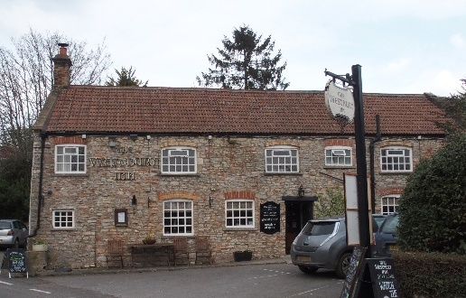

01749 870402
TAKEAWAY MENU Thur.-Sat.12-2pm & 5.00-8.00pm and Sunday 12 ‘til 2.30pm.
**Menu 16th- 20th December **
Order day before advised but try last minute orders.
Self-collection via 10 minute time slots but must stay outside the Pub.
Delivery can be arranged for £2.50 Westbury, Easton, Rodney and Draycott. Cheddar £3.50. Over 70s, living in Westbury-sub-Mendip, free.

STARTERS **************************
Vegetable spring roll with Hoisin sauce £4.50
Breaded deep fried brie with cranberry compote £5.00
Smoked mackerel pate, crusty bread £4.00
Prawn cocktail with Marie Rose sauce £5.00

MAINS **************************
Beer battered cod, chips and peas £10.00
Pheasant and partridge pie with veg and pots £12.00
Beef lasagne with salad and garlic bread £10.00
Wholetail scampi with chips peas and tartare sauce £10.00
Broccoli, spinach and macaroni cheese with salad & garlic bread £10.00
Quarter roast Duck with orange gravy, veg & pots £12.50
Chinese pork curry with rice and prawn crackers £10.00
Beef dansak with rice, papadum and mango chutney £10.00
Lamb Wellington with rosemary and redcurrant gravy, potatoes and veg £12.00

SOURDOUGH PIZZA 9’’ £10.00 or 12’’ £12.50
Mushroom, salami & truffle oil or Chorizo, chilli & red onion or Classic Margherita or Tuna, anchovy, garlic & black olive

PTO for Friday night special Main, Desserts and Sunday menu.
FRIDAY NIGHT SPECIAL MAIN:
Salmon fillet with crab & prawn mousse wrapped in filo pastry with white wine dill sauce £15.00

DESSERTS ************************** each £5.00

Chocolate brownie or Sticky toffee pudding or
Chef’s choice of Homemade cheesecake or Tiramisu
Please ask for Chef’s choice of flavour of above desserts

Sunday roasts from 12.00 ‘til 2.30pm.

SUNDAY TRADITIONAL ROASTS
Roast turkey, chipolatas, bacon rolls, stuffing £15.00
Beef, lamb, or pork £12.50
Poached salmon with lemon Hollandaise sauce £12.50

BEER, CIDER, LAGER 4pts from £10.00

DELIVERY CHARGES
Over 70s living in Westbury-sub-Mendip free.

£2.50 to Westbury-sub-Mendip, Easton, Rodney Stoke
& Draycott
£3.50 to Cheddar

01749 870402

