Ash Dieback – Frequently Asked Questions

What is ash dieback? Ash dieback is a serious disease of ash trees caused by a fungus that spreads through spores borne on the wind. It has only recently arrived in Britain but has now spread across the whole country. For reasons that are not altogether clear it has severely affected the Mendips.
What does ash dieback look like? Affected trees show dead and blackened leaves at the tips of branches and later whole branches in the crown of the tree die. Often there is a rash of extra side-shoots below the affected portion.
Is there a cure for ash dieback? There is no known cure for the disease and affected trees will usually die within 5 – 10 years. Some trees however will survive longer than others depending on their age (saplings are especially vulnerable) circumstances (those on exposed sites are more at risk) and precise genetic makeup
How can I stop the spread? There is no way to stop the spread of the disease; millions of spores are carried on the air from infected trees and it is expected that 85-90% ash trees will contract it and die within 10 years
Are some ash trees immune? There is some evidence that a very small proportion of trees have at least partial immunity. Older trees have more resistance than young but that slows the progress rather than preventing infection. In the long term a resistant strain may appear through natural selection.
Will it affect trees other than ash? It does not appear to affect trees other than the ash; mountain ash, otherwise known as rowan, is not affected as it is a different species.
Are diseased trees dangerous? As the tree becomes affected by dieback it also become vulnerable to other infectious agents such as honey fungus which can weaken it and cause branches or even the whole tree to fall. These trees can become unstable and dangerous and it can be hard to understand what is happening inside the tree.
What is your responsibility with trees on your land? Landowners have a duty of care to users of roads and footpaths and need to get their trees regularly checked by a professional forester. Trees with more than 50% crown loss are hazardous.
What if the tree is by a road? If a tree is badly diseased (over 50% of the crown is affected) the landowner needs to take expert advice urgently as the tree may be a hazard for which they can be liable. It would be unwise to take one down without expert advice as the crown may be unsafe. Trees alongside footpaths and bridleways, or anywhere the public has access can also be a cause of concern and need to be monitored periodically. It is worth the landowner keeping a photographic record of any trees they decide to fell in case of subsequent challenge and to keep records to show that they have been monitoring ones that could cause a hazard.
Who is responsible if a tree falls into the road? The highways authority has the power to remove any tree that is obstructing the road but a landowner may be held responsible for any damage done by a tree growing on their property if it can be shown that they were negligent or careless in any way. If trees are showing signs of disease it would be best to take expert advice.
Do I need permission to cut a tree down? You need to check whether the tree is covered by a tree protection order or is in a conservation area. If you need to fell a number of trees a felling licence from Forest England is required which would last for 5 years. It would carry the expectation that you would replant (approximately 2 trees a quarter are exempt from the need for a felling licence) A guide to the law is here. Currently the fact that a tree has Ash Dieback is not by itself an accepted reason to cut down a tree but if it is a serious threat you may need to act quickly; if so keep records.
Should I cut diseased trees down immediately? Affected trees are brittle and can fail without warning. It is recommended that trees are cut down by professionals with suitable machinery. If the tree does not pose a danger to the public then it can be best to leave it for the continuing wildlife benefits of dead standing wood.
What is the effect on wildlife of dieback? The loss of many ash trees will have a serious effect on the many species of wildlife that depend on them. A dying tree however does offer food for different species (woodpeckers and hole nesting birds for example) so should be left wherever it is safe to do so.
Do I need to bother bringing in a tree surgeon? Affected trees do not always behave predictably because of additional infections which may not be evident. It is strongly recommended to take expert advice before tackling large and heavily diseased trees.
What trees make a good replacement for ash? No one tree can replace the environmental benefits of ash so a mix of replacement tree species is recommended. In this area oak, small leaved lime, field maple, hornbeam, wych elm, whitebeam and sycamore all have a part to play.
Can I get financial help to deal with the effects of ash dieback? There are currently no government schemes that provide financial assistance with the costs of dealing with ash dieback. You should check your insurance however as some policies may offer cover.
Where can I get advice? There are many sources of advice on line such as this produced by the tree council. A qualified tree surgeon will also be well placed to advise about individual trees and the disease in general.

Ash trees near Westbury showing the effects of die back – loss of leaves in summer

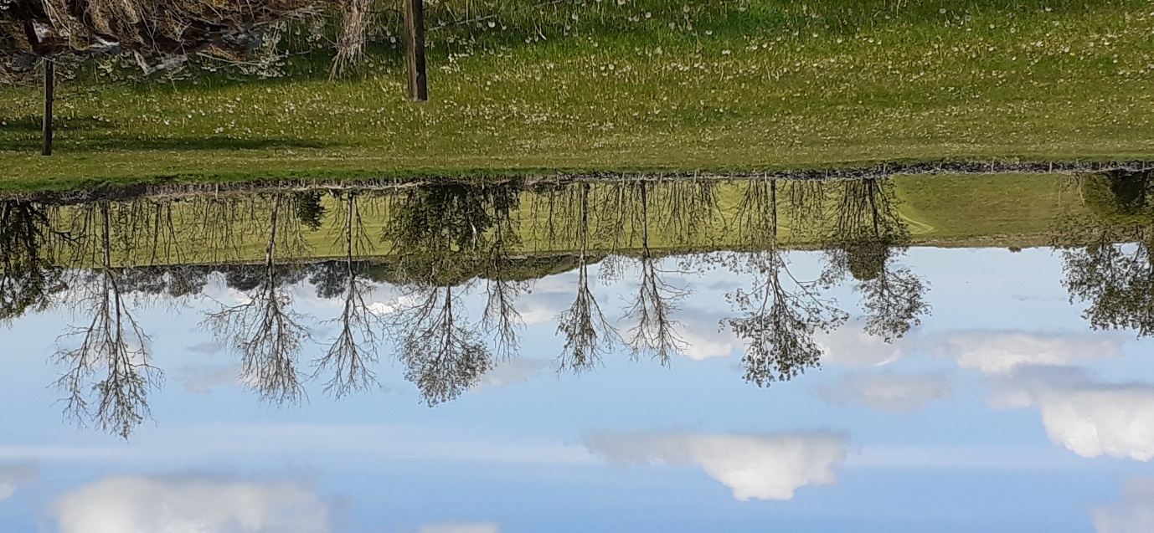

This notice has been produced by the Westbury Parish Council Tree Group for the information of residents. To contact the group please email buffyfletcher@hotmail.com

