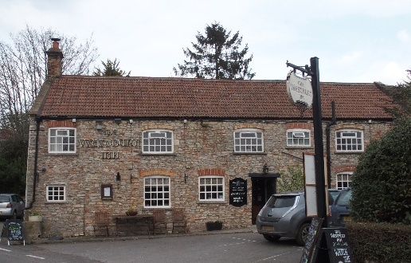

01749 870402

24th November 2020 Update.

Dear All, I, with Ann-Marie, have been running the Pub in this ‘time of Covid-19’ since March. We have had times of complete lock-down, times of ‘Eating Out to Help Out’, and then times of lock-down again where we have only been able to do Takeaways. I and Ann-Marie and Adam have recently had Covid-19 tests through the site at Bristol Airport. 10 days ago we all tested negative but today following a second round of tests I have tested positive for Covid-19 while Ann-Marie and Adam have remained negative.

This means that I am now self-isolating for 14 days. It also follows that the Pub will be closed entirely. During this time, the Pub will be deep cleaned and suitably fogged so that it will be Covid-19 safe to re-open in due course. 14 days takes us to Wednesday 9th December which is a possible date for reopening the business. Given the commercial difficulties of these last 9 months I am very concerned about how the Pub can remain a viable business. However, after these 14 days, and Somerset including Mendip has entered tier 2, following the current lock-down, I hope that it will be possible for the Pub to be open again. All the staff will have had a Covid-19 test before any such opening. We will continue to be in need of your understanding and support which you have so freely given since I took over the Pub, as the landlord, several years ago.

Take care. Andy Jones and Ann-Marie.

