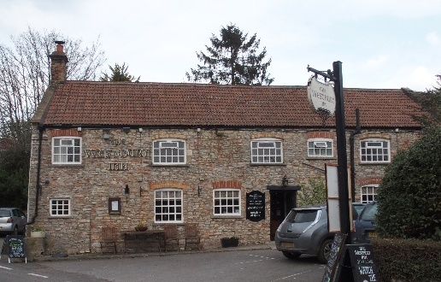

01749 870402
TAKEAWAY MENU Thur.-Sat.12-2pm & 5.00-8.00pm and Sunday 12 ‘til 2.30pm.
**Menu 19th- 22nd November **
Self-collection via 10 minute time slots but must stay outside the Pub.
Delivery can be arranged for £2.50 Easton, Rodney and Draycott. Cheddar and Wells £3.50. Free delivery for those living in Westbury-sub-Mendip.

STARTERS **************************
Breaded Whitebait with tartare sauce £5
Chicken liver pate with red onion chutney and warm toast £4.50
Breaded deep fried brie with cranberry compote £5.50

MAINS **************************
Beer battered cod, chips, and peas £10
Steak and ale shortcrust pastry pie with veg. & pots. £10
Beef lasagne with salad and garlic bread £10
Wholetail scampi with chips peas and tartare sauce £10
Hearty vegetable stew with suet dumplings £10
Buttered chicken curry with rice and poppadum £10
Fish pie topped with cheesy mash, peas, and crusty bread £12
Venison and redcurrant casserole, herb dumplings & veg. £12
Lamb Wellington with rosemary and redcurrant gravy, potatoes and veg. £12
Confit of whole partridge with sherry and mushroom sauce, potatoes and veg. £12

SOURDOUGH PIZZA 9’’ £10 or 12’’ £12.50
Mushroom, salami & truffle oil or Chorizo, chilli & red onion or Classic Margherita or Tuna, anchovy, garlic & black olive

PTO for Desserts and Sunday menu.

DESSERTS ************************** each £5.00

Chocolate brownie or Sticky toffee pudding or
Chef’s choice of Homemade cheesecake or Panna cotta with mixed berry compote and brandy snap crisp or Homemade bread and butter pudding or Hot baked rum bananas

Please ask for Chef’s choice of flavour of above desserts

Sunday roasts from 12.00 ‘til 2.30pm.

SUNDAY TRADITIONAL ROASTS £12.50
Beef, lamb, or pork
Poached salmon with lemon Hollandaise sauce £12.50

BEER, CIDER, LAGER 4pts from £10.00

DELIVERY CHARGES

Free delivery for those living in Westbury-sub-Mendip.

£2.50 to Easton, Rodney Stoke & Draycott

£3.50 to Cheddar and Wells.

01749 870402

