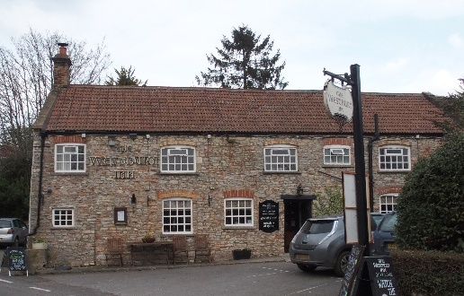

01749 870402
TAKEAWAY MENU Thur.-Sat.12-2pm & 5.00-8.00pm and Sunday 12 ‘til about 3.00pm
**Menu 12th- 15th November **
Order day before advised but try last minute orders.
Self-collection via 10 minute time slots but must stay outside the Pub.
Delivery can be arranged for £2.50 Westbury, Easton, Rodney and Draycott. Cheddar £3.50. Over 70s, by arrangement, free.

STARTERS **************************
Buttermilk Cajun chicken strips with chilli dip £5
Chicken liver pate with red onion chutney and warm toast £4.50
Soup of the day with crusty bread £4

MAINS **************************
Beer battered cod, chips and peas £10
Steak and ale shortcrust pastry pie with veg. & pots. £10
Beef lasagne with salad and garlic bread £10
Sweet ‘n’ sour pork Hong Kong style with rice and prawn crackers £10
Breast of chicken madras curry with rice and poppadum £10
Liver & bacon casserole with onion gravy, mash pots. & veg. £10
Hearty vegetable stew with suet dumplings £10
Beef stroganoff with rice £10
Butchers faggots with mash, peas and onion gravy £10

SOURDOUGH PIZZA 9’’ £10 or 12’’ £12.50
Mushroom, salami & truffle oil or Chorizo, chilli & red onion or Classic Margherita or Tuna, anchovy, garlic & black olive

PTO for Puddings and Sunday menu.

PUDDINGS ************************** each £5.00

Chocolate brownie or Sticky toffee pudding or
Chef’s choice of Homemade cheesecake or Panna cotta with mixed berry compote and brandy snap crisp or Homemade bread and butter pudding or Hot baked rum bananas

Please ask for Chef’s choice of flavour of above desserts

Sunday roasts from 12.00 ‘til 3.00pm!

SUNDAY TRADITIONAL ROASTS £12.50
Beef, lamb, or pork
Poached salmon with lemon Hollandaise sauce £12.50

BEER, CIDER, LAGER 4pts from £10.00

DELIVERY CHARGES
£2.50 to Westbury-sub-Mendip, Easton, Rodney Stoke
& Draycott
£3.50 to Cheddar

FREE DELIVERY to the over 70s
(also, for you, we can supply provisions and please don’t hesitate to call and speak to Andy or Ann-Marie to take your order)

01749 870402

