28 September 2020
Dear All,

As autumn comes upon us and the evenings draw in let’s continue to keep up the levels of support we have managed to provide one another and not be disheartened by the need to continue with our anti-virus precautions. The parish emergency planning group will keep up their excellent work in keeping us all informed and sharing their knowledge of latest developments within the village and beyond.
The Parish Council starts the autumn with some changes of personnel. Firstly Peter Bright, who had served on the council since 2006 resigned to give more time to his natural history interests. He has been an invaluable voice of sense at our meetings and will be sorely missed. We thank him for his years of service. However, we have now co-opted a new councillor who will soon make her mark. We welcome Buffy Fletcher of Old Ditch Farm to our ranks. She has already initiated the village tree group and will ensure the council takes a strong position on ecological matters.
We have also lost our clerk, Chris Harris, to the demands of a full time job and further studying. Our advertisement for a replacement did not yield us a satisfactory replacement, so we have sought to find a locum clerk for a six month period while we regroup and encourage local talent to step forward. Our interim clerk is Sam Peake who is already clerk for Shipham Parish Council and assists at Cheddar too. She is experienced in local government business and I am most grateful to her for taking on our council at short notice. We look forward to working with both Buffy who joined the council in August and Sam who starts with us today.
Our next meeting is on 7 October and the agenda will be available on the notice boards and website by the end of the week. Normally we encourage applications for grants to local organisations at this meeting, but because of the delay in recruiting a new clerk we will now take applications across both October and November, final closing date Weds 29 October. Further details and an application form are available on the village website or you may contact me directly.
Keep strong and keep safe.

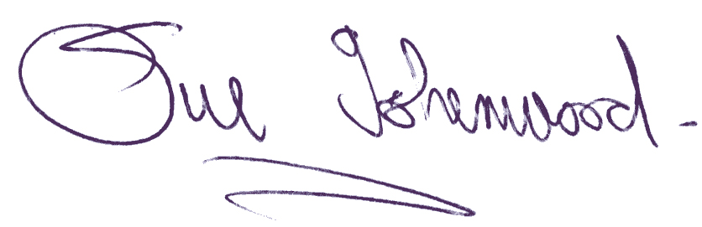
Sue Isherwood, Chair Westbury-sub-Mendip Parish Council sueisherwood9@gmail.com 01749 870457

