Hi everyone,

As you may know, the Strawberry Line route through Wells is difficult, with sections built from Dulcote to the Sherston Inn, and the Leisure Centre to Haybridge, but nothing in between, and three busy roads to cross (Portway, Tucker Street and Priory Road).

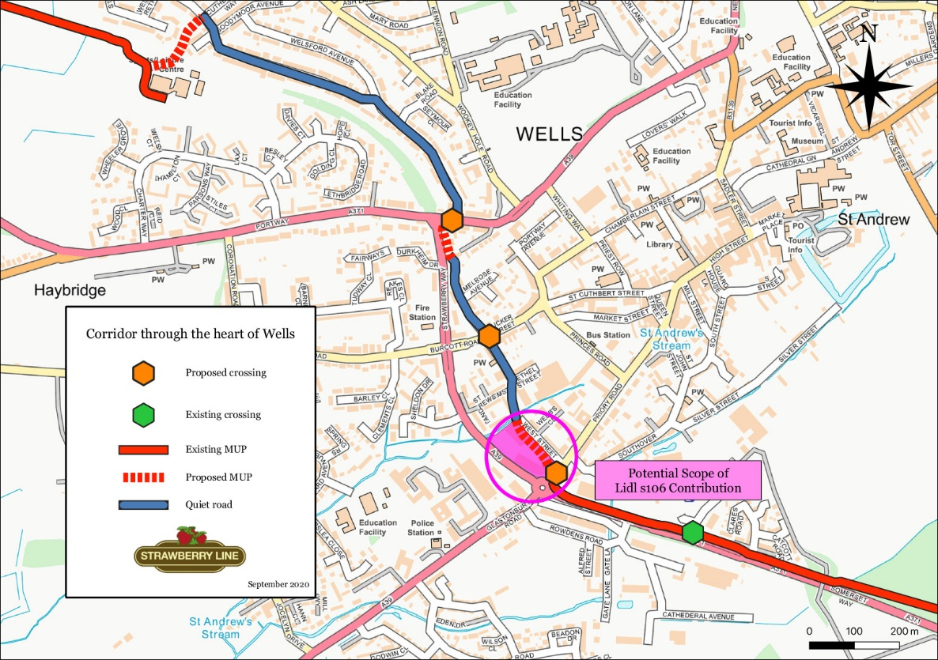

However, Lidl have now applied to demolish the Travis Perkins site, and build a bigger supermarket next to their existing one, which is right on the Strawberry Line route!

Despite this, their plans do not give any room for a cycle route. If they go ahead, it will permanently prevent a dedicated cycle path from being built here, and we need public support to make the case that they should give back to the community by building a dedicated cycle route through their site, and good crossing on Priory Road for both pedestrians and cyclists!

To do this they would only need to move their proposed buildings by about 1.5m, and it would be a great opportunity for Lidl to boost their local image, and be right on a long distance multi-user route!

But we need as many people to raise these points in the planning process as possible, to build a strong case to make sure they do their part! Please do submit a comment on the planning application [here (application 2020/1616/FUL)](https://publicaccess.mendip.gov.uk/online-applications/applicationDetails.do?activeTab=makeComment&keyVal=QFQ9SXKPFI500), share it with anyone else you know who might be able to help, and help to make sure the right infrastructure is put in now, or the opportunity may be lost forever!

Many thanks,

Matt