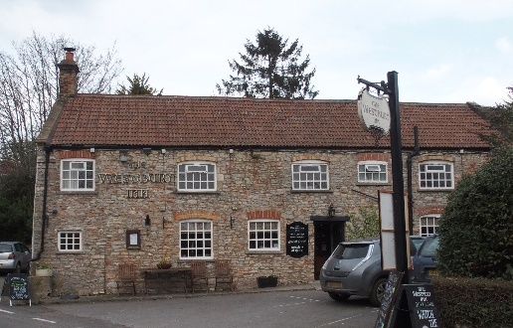

01749 870402
TAKEAWAY MENU Mon.-Sat.12-2pm & 5.30-7.30pm
**Menu 9th- 13th September **
Order day before advised but try last minute orders.
Self-collection via 10 minute time slots so only one person in pub at a time!
Delivery can be arranged for £2.50 Westbury, Easton, Rodney and Draycott. Cheddar £3.50. Over 70s, by arrangement, free.

STARTERS **************************
Fresh salmon and parsley fishcakes with tartare sauce £5
Chicken liver pate with red onion chutney and warm toast £4.50
Soup of the day with crusty bread £4

MAINS **************************
Beer battered cod, chips and peas £10
Wholetail scampi, chips and peas £10
Steak and ale shortcrust pastry pie with veg & pots £10
Beef lasagne with salad and garlic bread £10
Sweet ‘n’ sour pork Hong Kong style with rice and prawn crackers £10
Breast of Chicken Kiev with chips and salad £12.50
Chinese style chicken curry with rice and prawn crackers £10
8ozs beef burger with salad and chips £10
ADD cheese £1.50 ADD bacon £1.50

SOURDOUGH PIZZA 9’’ £10 or 12’’ £12.50
Mushroom, salami & shaved truffle or Chorizo, chilli & red onion or Classic Margherita or Tuna, anchovy, garlic & black olive

Please call for fresh fish availability and Weekly specials.

PTO for Puddings and Sunday menu.

PUDDINGS ************************** each £5.00

Chocolate brownie or Sticky toffee pudding or
Chef’s choice of Homemade cheesecake or Panna cotta with mixed berry compote and brandy snap crisp or Homemade bread and butter pudding

Please ask for Chef’s choice of flavour of above desserts

Sunday roasts from 12.00 ‘til 2.30pm! menu 5-6pm

SUNDAY TRADITIONAL ROASTS £12.50
Beef, lamb, or pork
Poached salmon with lemon Hollandaise sauce £12.50

BEER, CIDER, LAGER 4pts from £10.00

DELIVERY CHARGES
£2.50 to Westbury-sub-Mendip, Easton, Rodney Stoke
& Draycott
£3.50 to Cheddar

FREE DELIVERY to the over 70s
(also, for you, we can supply provisions and please don’t hesitate to call and speak to Andy or Ann-Marie to take your order)
01749 870402

