31st August 2020
Dear All,
At the risk of boring you I thought I should return to discussion of planning matters. At the end of my last letter I mentioned that commenting on planning applications is a major part of the Council’s work on your behalf. I then asked you for your ideas concerning village growth and development. Thank you to all those who have taken the trouble to respond - and more thoughts and ideas are always welcome.
People are particularly concerned about more houses being built in the village, where they might go and how many might be affordable for young renters and first-time buyers. I thought it might be useful to state again some of the key points about where we are with planning matters.
Currently, the Mendip District Local Plan suggests that Westbury-sub-Mendip is seen as a primary settlement. (It has a school, pub, shop and community playing field and hall.) As such it also has designated green spaces and an allocation of a minimum of 40 new houses. The draft plan part 2 further suggests that the field on the main road behind Court Farm and Mortar Pits would be favoured for development. The draft plan part 2 is with the Planning Inspectorate and nothing will happen until it is reviewed and approved there. This may take some time as Central Government is putting forward new legislation designed to speed up the planning process and incidentally reducing the role of local authorities (including parishes) in detailed scrutiny of planning applications. The inspector may wish to delay until new legislation is passed, by which time local plans may well be rendered largely redundant. However, any landowner can of course put forward an application at any time, regardless of the local plan.
Currently Mendip District Council has had no approach, preliminary or more formal, from the Church Commissioners who own the land in question. They cannot comment on an application they have not received and nor, of course, can the Parish Council. The demand for new housing is critical across the whole country and we will need to accept new houses here. Where they go and what they look like is still an open question. We know there will be development, but we cannot make even an intelligent guess at where, when or how much. What we can do is be prepared by having an open debate, respecting inevitable differences of opinion and trying to agree among ourselves how we would like our beautiful village to grow.
Keep the ideas flowing and continue to keep safe,
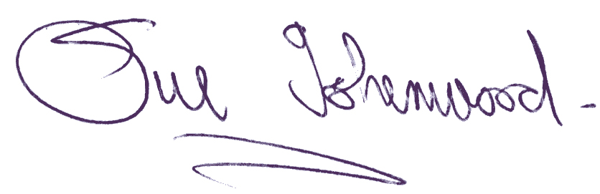
Sue Isherwood, Chair Westbury-sub-Mendip Parish Council sueisherwood9@gmail.com 01749 870457

