News from the Village Hall
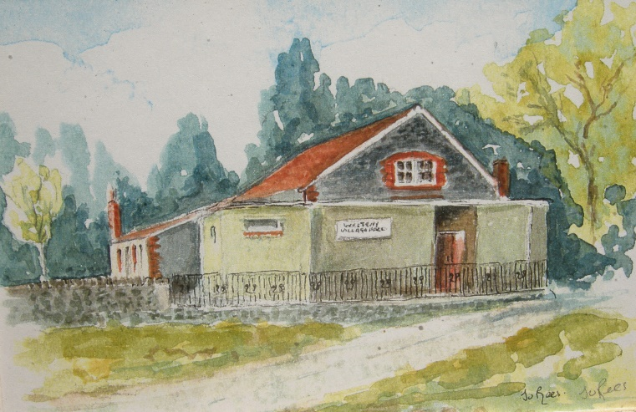

The Village Hall has been closed since the beginning of March but there are plans for some activities to start again from 7th September. Thank you to all those who filled in the on-line questionnaire to assess the interest in activities returning to the Hall.
Since March you may have noticed that the Hall has had a new coat of paint on the outside and on the window frames and is looking very smart. Inside some long delayed small electrical works are due to be finished before the end of August so that they will be less piecemeal.

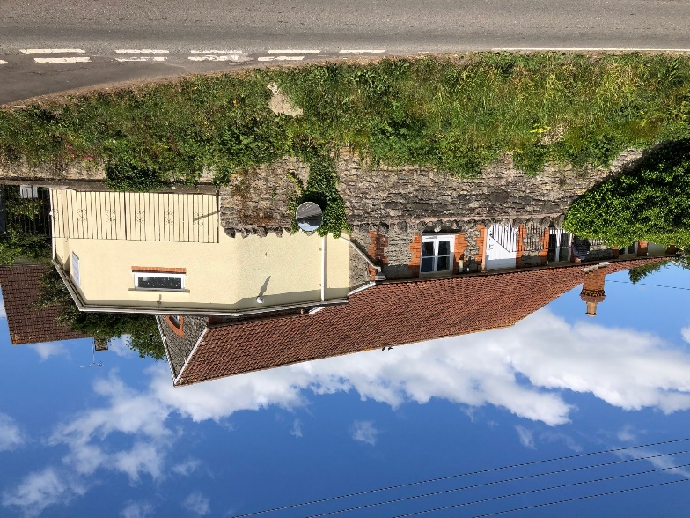

There has been an abundance of Government guidance and its interpretation by ACRE, Action with Communities in Rural England. Changes and updates are continuous. We think that it is going to be within government guidelines for the Hall to open but with a series of restrictions and requirements.
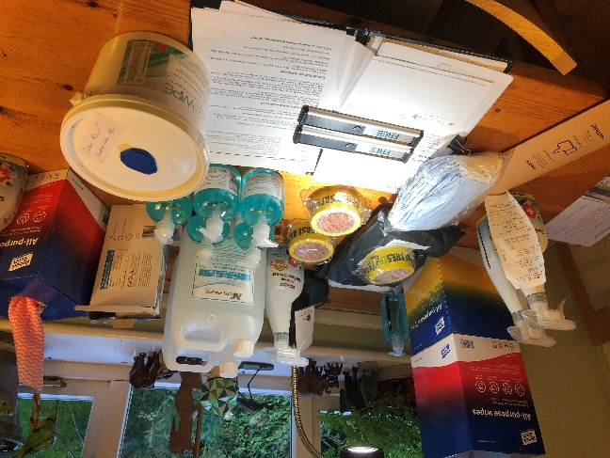 Sprays, antiseptic wipes, hand gel and…
Social distancing of 2m means that to all intents and purposes the maximum numbers permitted for a ‘meeting’ is 20. Antivirus wiping of all surfaces, tables, chairs, switches, door handles etc before an activity and then again after the activity are going to be essential. Wearing masks is also required unless you are the speaker. One-way flow through the Hall in the front door and out through the kitchen. Hand sanitising as you come in and as you leave the hall. Toilets strictly one in one out. Hand sanitiser going in and antiviral wipes of surfaces you touch and hand sanitiser coming out. It seems unlikely that the kitchen will be safely usable at the moment, along with coffee and biscuits being a step too far. Each activity will have its own agreed risk assessment and what the organiser is undertaking to make making sure happens. This includes a complete list and contact numbers for everyone that comes to the Hall in case it is needed for ‘Track and Trace.’ In other words, it requires all the Hall users to be thoughtful and meticulously careful.
Activities that are planning to start to use the Hall, probably in the week beginning the 7th September, are Gardening Club, Table Tennis, Art Group along with Kettlercise. There may be some small ensemble music rehearsals. It is possible that the WI and the Film Club might start in October along with Westbury Society though the latter is likely to move to the third Tuesday in the month. If you have an activity that you would like to use the Hall for, please contact me so that the possibilities can be discussed. Peter Bright peterbright60@btinternet.com 01749 870640

