13th July 2020

Dear All,

I am sure that like me you have welcomed signs that the village is returning to something more normal; being able to browse inside the shop, eat at the pub or have your hair done. We are not over this by any means, but we are learning to live with the virus and are able perhaps to think about other things. That is why the Parish Council agreed that the Emergency Plan team could reduce their regular updates to once per week (unless of course something needs urgent action)
In the same spirit I am suggesting that as the need for regular communication about COVID hopefully reduces, the updates carry more information about matters of more general interest for residents. It would be good to have a means of communicating about non COVID matters that affect us all such as road closures or changes to recycling. Keeping the updates going while there is little new on the COVID front would mean that we still have a system in place ready to react quickly when there is a sudden flare up or significant changes to guidance.
I’d be interested in your thoughts on this as well as other Parish Council matters. Please get in touch with me by using my contacts below.
Keep safe.

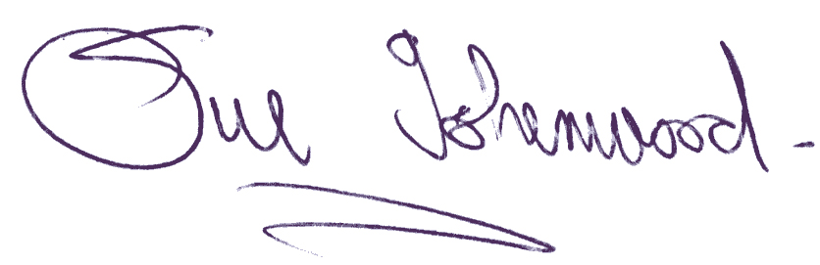
Sue Isherwood, Chair Westbury-sub-Mendip Parish Council sueisherwood9@gmail.com 01749 870457

