27 July 2020

In my last parish letter I raised the question of the future of the coronavirus updates and sought feedback about continuing to publish them but bringing in a wider range of issues. I’m pleased to say that I’ve received no objections or brickbats and a number of supportive comments. One message in particular, from Linda Mogford, I’d like to quote in full. Linda says
“Sue Isherwood, Parish Council Chairperson sent a letter last week asking for feedback. This is mine.
As we begin to look forward we should all give grateful thanks for the work set in motion by the Emergency Plan Committee. This committee was set up by the Parish Council sometime ago. Now that it is needed, led by Sue Reece and Mick Fletcher, it has worked with great energy to foster fantastic community spirit. We have been encouraged and supported to offer and receive help in all kinds of ways both large and small. Some other local communities have not had such good leadership and organisation. So we must say a huge thank you especially to Sue and Mick and the shop but also to all the unsung volunteers who have supported us in so many ways.”
I’d like to add my own thanks to Linda’s.
On wider matters I was interested to note that the Parish Council received a very useful report on ways of reducing the alarming decline in insects that we are seeing countrywide at the same time as a report from Mendip on creating wild flower areas, including one in Westbury (see the update for details). And as you know we have also supported a tree group to ensure a healthy future for our woodland areas and hedgerows (see new section on the village website). I’d like to start a debate in the village about how we can support these important initiatives.
If you have ideas please contact me.
Keep safe.

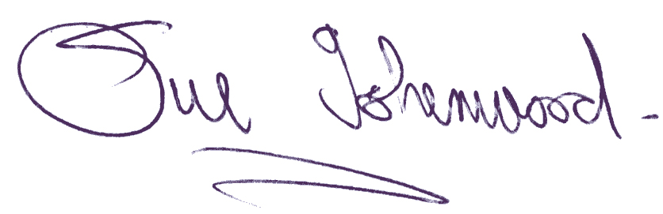
Sue Isherwood, Chair Westbury-sub-Mendip Parish Council
Sueisherwood9@gmail.com Tel 01749 870457

