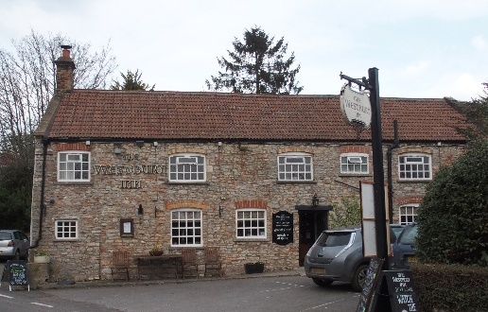

01749 870402

‘Eat out to help out!’
The Chancellor of the Exchequer is supporting eating out on a Monday, Tuesday, or Wednesday in August. Andy and the Westbury Inn are now registered for this offer.

He is offering 2 options:

- Table d’hôte 3 course menu for £20.
There will be 3 versions – Meat, Fish or Vegetarian.
The exact menu for these choices will be changed each week.

- A high value single course menu for £20 or £25.
This is likely to be offers like fillet steak or rack of lamb. The exact offers will be changed each week.

The offer will start on Monday 3rd August and continue every Monday, Tuesday and Wednesday until the last on Monday 31st August. You will need to book a table and your choices directly with the Pub. 01749 870402

In practice it is expected that, with the subsidy, the Table d’hôte menu will cost you, the diner, £10 and the single course version £10 or £15.

The complete details of how the scheme will operate have not yet been published so that this offer is subject to it fitting with the details of the scheme when they are eventually known.

The State subsidised offer will not apply to any takeaway menus or the standard menus offered in the Pub. The administrative burden is likely to be high and hence the limited offers.

Andy Jones 27th July.

01749 870402

