29th June 2020

Dear All,
From next Saturday we will be able to socialise more. Locally our wonderful pub will reopen, our playing field will unlock its gates and we can all queue up to get our unruly hair seen to by The Cutting Room.
Of course, we are not out of the woods yet, as the continuing rise in positive Covid 19 reports in some American states and hot spots in Germany and closer to home in Leicester demonstrate. The great majority of people in this village have played by the rules and I am sure will continue to do so. I thank you all for your tolerance so far and your continuing observance of safety regulations. The health of the whole community depends on this.
Now, while the lock down is eased there are fewer day to day news updates to give you, so our dedicated emergency plan team of Sue Reece and Mick Fletcher are thinking of reducing their bulletins to one a week. Of course, if there’s any big change we will issue an extra notice. Do let us know whether you are happy to hear less from us.
Meanwhile all the support systems put in place back in March and early April are still there for you to use, including the Friendly Society’s special support fund. I have asked for another copy of our helpline summary to be included with the update in case anyone needs to refresh their memory. Please let us know what is most useful for you and we will find ways to ensure it continues to exist in the longer term.
Thank you again for being such an active and engaged community.
Keep safe.

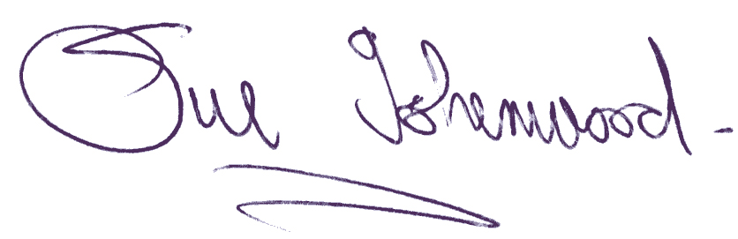
Sue Isherwood, Chair Westbury-sub-Mendip Parish Council 01749 870457

