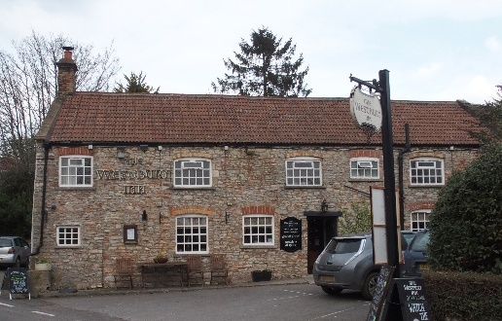

01749 870402
TAKEAWAY MENU Mon.-Sat.12-2pm & 5.30-7.30pm
***Menu for 24th to 28th June 2020 ***
Order day before advised but try last minute orders.
Self-collection via 10 minute time slots so only one person in pub at a time!
Delivery can be arranged for £2.50 Westbury, Easton, Rodney and Draycott. Cheddar £3.50. Over 70s, by arrangement, free.

STARTERS **************************
Lightly dusted calamari with sweet chilli dip £5
Pink goose breast with fresh mango salad £5
Smoked salmon and fresh dill cream cheese cornets £5

MAINS **************************
Beer battered cod, chips and peas £10
Wholetail scampi, chips and peas £10
Steak and ale shortcrust pastry pie with veg & pots £10
Beef lasagne with salad and garlic bread £10
Beef burritos (rice and BBQ beef) with melted cheese and salad £10
Spicy stir-fried chicken noodles in coconut cream sauce and
prawn crackers £10
King prawn and cod linguini with salad and garlic bread £12.50
Breast of Chicken kiev with chips and salad £12.50
SOURDOUGH PIZZA 9’’ £10 or 12’’ £12.50
Mushroom, salami & shaved truffle or Chorizo, chilli & red onion or Classic Margherita or Tuna, anchovy, garlic & black olive

PTO for Specials and Puddings.

LOBSTER SALAD SPECIAL - £15
Friday 26th June 2020 Please pre-order to avoid disappointment

PUDDINGS ************************** each £5.00

Chocolate brownie or Sticky toffee pudding or
Chef’s choice of Homemade cheesecake or Vanilla panna cotta with mixed berry compote and shortbread or Banana and sultana bread and butter pudding

Sunday roasts from 12.00 ‘til 2.30pm! menu 5-7pm

SUNDAY TRADITIONAL ROASTS £12.50
Beef, lamb, or pork
Poached salmon with white wine, dill cream sauce £12.50

BEER, CIDER, LAGER 4pts from £10.00

DELIVERY CHARGES
£2.50 to Westbury-sub-Mendip, Easton, Rodney Stoke
& Draycott
£3.50 to Cheddar

FREE DELIVERY to the over 70s
(also, for you, we can supply provisions and please don’t hesitate to call and speak to Andy or Ann-Marie to take your order)
01749 870402

