15th May 2020

In my previous message as Chair of the Parish Council I passed on the thanks of the whole Council to those who have stepped up to volunteer their help to the community during the pandemic, as well as those who have continued to work in difficult circumstances in village organisations such as the Community Shop. We remain grateful to all of you for your efforts as well as to all those who are key workers or are keeping important local businesses going.
Today I would like to add to those thanks our appreciation of those who are simply acting as good neighbours. Much of this work is invisible to most of us, but going around the village I have noticed, for example, the newly repainted bench outside the shop, the similar refurbishment of the bench and its surrounds in the square and the fact that the bench along Drappel Lane has been rescued from the brambles. The telegraph poles look much better for the recent clean up (though there remain a few to be adopted) and for the addition of the posters created by Westbury children – many thanks for cheering us up! I also understand that the phone box / library will shortly be repainted. These actions all help the quality of life here in Westbury and help make the restrictions on our lives easier to bear.
Finally, could I thank all those responsible dog walkers who pick up after their pet on their walks around the village and encourage the few who do not to start doing so. A number of people have remarked on an increase in fouling on popular routes. As a Council we had already decided not to take on the heavy expense of installing dog poo bins and would still much prefer to rely on the good sense of residents in keeping our lanes and footpaths clean.
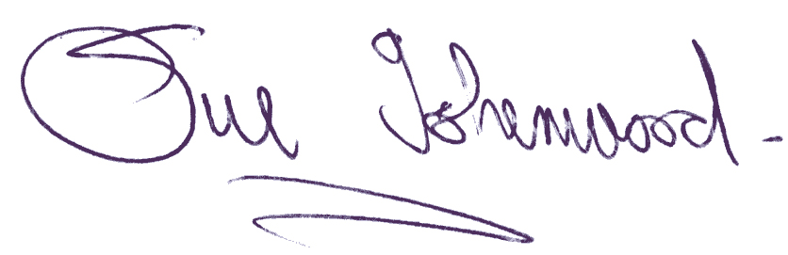
Sue Isherwood, Chair Westbury-sub-Mendip Parish Council

