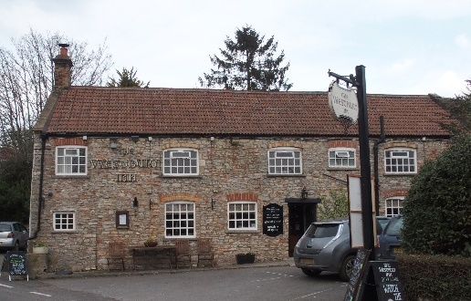

01749 870402
TAKEAWAY MENU Mon.-Sat.12-2pm & 5.30-7.30pm
***Menu for 25th to 31st May 2020 ***
Order day before advised but try last minute orders.
Self-collection via 10 minute time slots so only one person in pub at a time!
Delivery can be arranged for £2.50 Westbury, Easton, Rodney and Draycott. Cheddar £3.50. Over 70s, by arrangement, free.

STARTERS **************************
Lightly dusted chiperoles with sweet chilli dip. £5.00
Salmon and dill fishcakes with tartare sauce. £4.50
Roasted stilton stuffed mushrooms. £5.00
MAINS **************************
Beer battered cod, chips and peas. £10
Wholetail scampi, chips and peas. £10
Chicken & ham shortcrust pastry pie with veg & pots. £10
Beef lasagne with salad and garlic bread. £10
8ozs beef burger with chips and salad. £10
ADD Bacon £1.50 ADD Cheese £1.50
Mediterranean vegetable ricotta and pasta bake with salad and garlic bread £10
Poached cod with a ginger and sesame broth with broad beans, broccoli, and new pots. £12.50
Chicken passanda with basmati rice, poppadum and mango chutney. £10
Beef chilli enchiladas with melted cheddar and salad. £10
Braised summer lamb with mint pesto, summer veg and new pots £12.50

FRIDAY 29th MAY EVENING SPECIAL Please pre-order as limited.

Half Rotisserie Chicken with salad and chips £12.50

PTO for Stop Press and Puddings.

STOP PRESS!!

FRIDAY 5TH JUNE 2020…PRE-ORDER ONLY
North Devon Half Lobster salad with chips. £15
Due to high demand please order early

PUDDINGS ************************** each £5.00

Chocolate brownie or Sticky toffee pudding or
Date and banana bread and butter pudding or
Cadburys’ crunchie cheesecake

Sunday roasts from 12.00 ‘til 2.30pm! menu 5-7pm

SUNDAY TRADITIONAL ROASTS £12.50
Beef, lamb, or pork
Poached salmon with lemon hollandaise. £12.50

BEER, CIDER, LAGER 4pts from £10.00

DELIVERY CHARGES
£2.50 to Westbury-sub-Mendip, Easton, Rodney Stoke
& Draycott
£3.50 to Cheddar

FREE DELIVERY to the over 70s
(also, for you, we can supply provisions and please don’t hesitate to call and speak to Andy or Ann-Marie to take your order)
01749 870402

