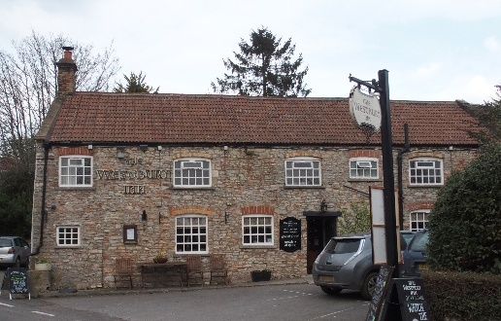

01749 870402
TAKEAWAY MENU Mon.-Sat.12-2pm & 5.30-7.30pm
***Menu for 11th to 17th May 2020 ***
Order day before advised but try last minute orders.
Self-collection via 10 minute time slots so only one person in pub at a time!
Delivery can be arranged for £2.50 Westbury, Easton, Rodney and Draycott. Cheddar £3.50. Over 70s, by arrangement, free.

STARTERS **************************
Duck liver pate with red onion marmalade and toast. £4.00
Salmon and dill fishcakes with tartare sauce. £4.50
Deep fried breaded brie wedges with apple compote. £5.00
MAINS **************************
Beer battered cod, chips and peas. £10
Wholetail scampi, chips and peas. £10
Steak and ale shortcrust pastry pie with veg & pots. £10
Braised breast of pheasant wrapped in bacon, braised in cider with veg & pots £10
Bone in pork chop with sautéed mushrooms, onions, tomato, peas and chips. £12.50
Chinese chicken curry with rice and prawn crackers. £10
Fresh cod and king prawn linguini with garlic bread. £12.50
Beef lasagne with salad, garlic bread and coleslaw. £10
8ozs beef burger with fried onions, chips and salad. £10
ADD Bacon £1.50 ADD Cheese £1.50
Root vegetable, tomato and stilton shortcrust pastry pie, onion gravy, veg & pots. £12.50
Half rack of BBQ baby back pork ribs with corn on the cob, coleslaw and chips. £12.50

FRIDAY 15th MAY SPECIAL – available lunch & dinner
Half Fresh North Devon Lobster with salad and chips. £15.00
Very, very limited!!! PRE –ORDER PLEASE.
For Puddings PTO

PUDDINGS ************************** each £5.00

Chocolate brownie or Sticky toffee pudding or
Date and banana bread and butter pudding or
Cadburys’ crunchie cheesecake

Sunday roasts from 12.00 ‘til 2.30pm! menu 5-7pm

SUNDAY TRADITIONAL ROASTS £12.50
Beef, lamb or pork
Poached salmon with tomato and basil sauce £12.50

BEER, CIDER, LAGER 4pts from £10.00

DELIVERY CHARGES
£2.50 to Westbury-sub-Mendip, Easton, Rodney Stoke
& Draycott
£3.50 to Cheddar

FREE DELIVERY to the over 70s
(also, for you, we can supply provisions and please don’t hesitate to call and speak to Andy or Ann-Marie to take your order)
01749 870402

We are going to take a break so there will be no food on the evening of Sunday 17th through to Sunday 24th May. Back again on Monday 25th May.
Thank you for your continued support.
Gone Fishing…………

