(Not) Daffodils
(With apologies to William Wordsworth this time)
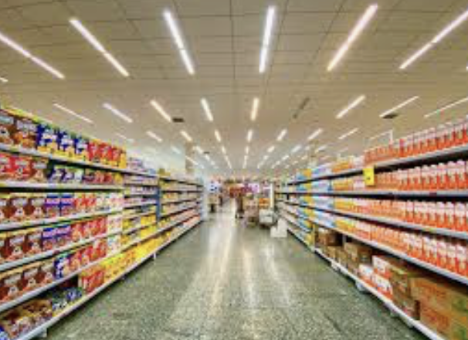

I wandered lonely as a cloud
That floats along o’er aisle and shelve,
When all at once I saw some flour
A stack of golden eggs, and oil
Beside the salt, beneath the rice
Fluttering, enticing in the light.

Continuous as the prawns in brine
And Twixes next the Milky Ways
The loo rolls stretched in glorious lines
Along the margins of the aisle;
Ten thousand items at a glance
Rustling their packs in enticing dance.
The juice beside them gleamed, but they
Out-did the sparkling wine and cheese.
A shopper could not but cave
In to such enticing company:
I gazed – and grazed – but little thought
The cost to me the show had brought.

For oft, when on my couch I lie
In bored or restless mood,
The Flash or bleach or cleaning wipe
Reveal the things of more to do.
So then I grab my cup of tea
And knuckle down to more KP.

