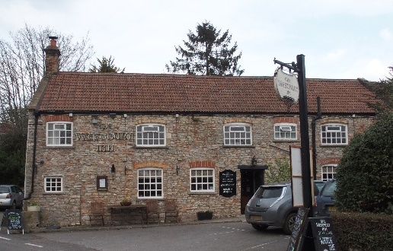

01749 870402
TAKEAWAY MENU Mon.-Sat.12-2pm & 5.30-7.30pm
***Menu for 4th to 10th May 2020 ***
Order day before advised but try last minute orders.
Self-collection via 10 minute time slots so only one person in pub at a time!
Delivery can be arranged for £2.50 Westbury, Easton, Rodney and Draycott. Cheddar £3.50. Over 70s, by arrangement, free.

STARTERS **************************
Chinese Barbeque spare ribs. £5.00
King prawn cooked in garlic butter. £5.50
Stuffed breaded mushrooms. £5.00
MAINS **************************
Beer battered cod, chips and peas. £10
Wholetail scampi, chips and peas. £10
Spaghetti bolognaise with garlic bread and salad. £10
Steak and ale shortcrust pastry pie with veg & pots. £10
Honey glazed boneless pork chop with apple sauce and
melted stilton with pots & veg. £12.50
Sweet and sour chicken balls with fried rice and prawn crackers. £10
Beef dansak (Indian curry) with rice and poppadum. £10
Chicken Kiev with chips and salad. £12.50
Salmon wrapped in filo pastry with white wine dill cream sauce,
served with pots & veg. £12.50
Red pepper and goat’s cheese quiche with chips and salad. £10
Braised lamb chop with red currant gravy, served with pots & veg. £12.50

FRIDAY NIGHT SPECIAL – 8th MAY
8ozs Rib eye steak, field mushroom, grilled tomato, peas and chips.£15.00
LIMITED pre-order now…

For Puddings and Friday 15th May extra special! PTO

FRIDAY 15th MAY SPECIAL – available lunch & dinner
Half Fresh North Devon Lobster with salad and chips £15.00
PRE –ORDER PLEASE

PUDDINGS ************************** each £4.00

Chocolate brownie or Hot baked rum bananas or
Lemon cheesecake with mixed fruit compote or
Sticky toffee pudding or Warm Bakewell tart.

Sunday roasts from 12.00 ‘til 3.00pm! menu 5-7pm

SUNDAY TRADITIONAL ROASTS £12.50

Beef, lamb or pork
Salmon wrapped in filo pastry with white wine and dill
cream sauce. £12.50

BEER, CIDER, LAGER 4pts from £10.00

DELIVERY CHARGES
£2.50 to Westbury-sub-Mendip, Easton, Rodney Stoke
& Draycott
£3.50 to Cheddar
FREE DELIVERY to the over 70s
(also, for you, we can supply provisions and please don’t hesitate to call and speak to Andy or Ann-Marie to take your order)
01749 870402

